**Exception Handling**

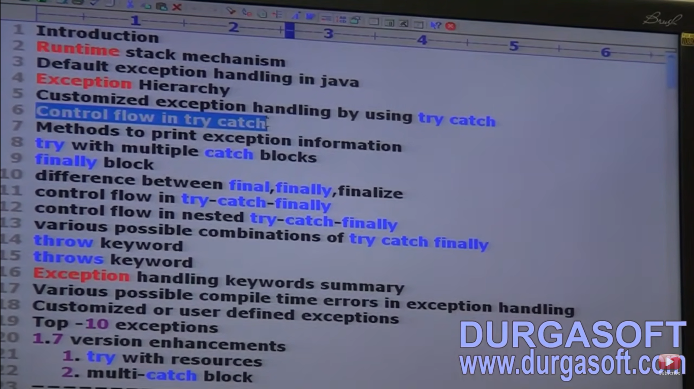

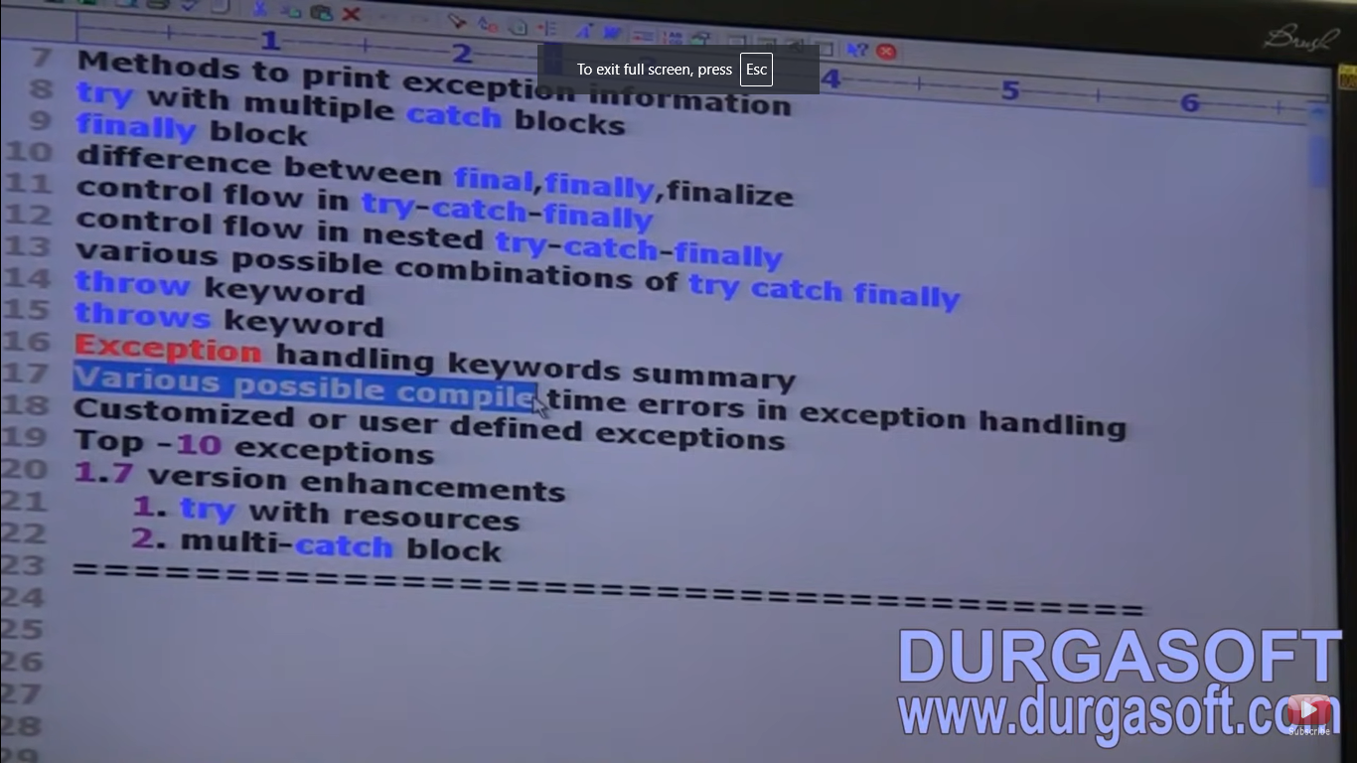

**Introduction**

An unexpected or unwanted event that disturbs the normal flow of the program is called an Exception.

Eg: TyrePuncheredException, SleepingException, FileNotFoundException etc.

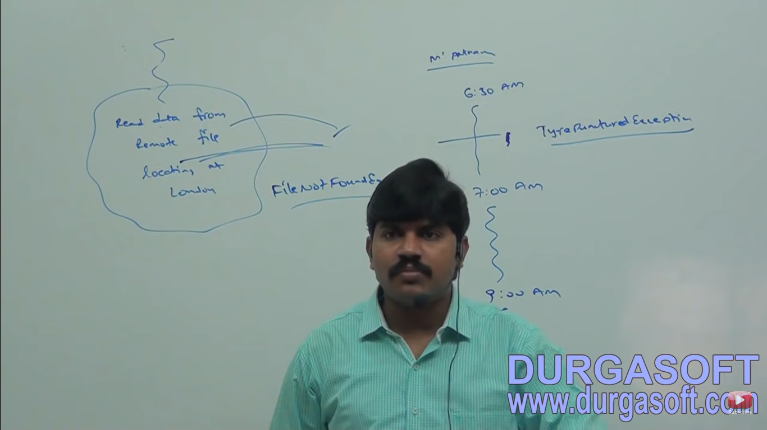

It is highly recommended to handle exceptions and the main objective of exception handling is graceful termination of the program.

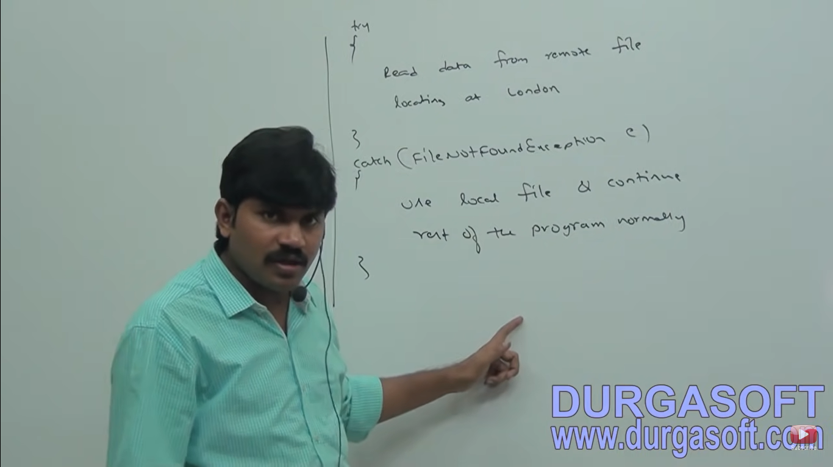

Exception Handling doesn’t mean repairing an exception we have to provide alternative way to continue rest of the program normally is the concept of exception handling. For eg: our programming requirement is to read the data from the remote file locating at London at runtime if London file is not available our program should not be terminated abnormally. We have to provide some local file to continue rest of the program normally. This way of defining alternative is nothing but exception handling.

**Runtime Stack Mechanism**

For every thread JVM will create a runtime stack. Each and every method call performed by that thread will be stored in the corresponding stack. Each entry in the stack is called stack frame or Activation record. After completing every method call the corresponding entry from the stack will be removed. After completing all method calls the stack will become empty and that empty stack will be destroyed by JVM just before terminating the thread.

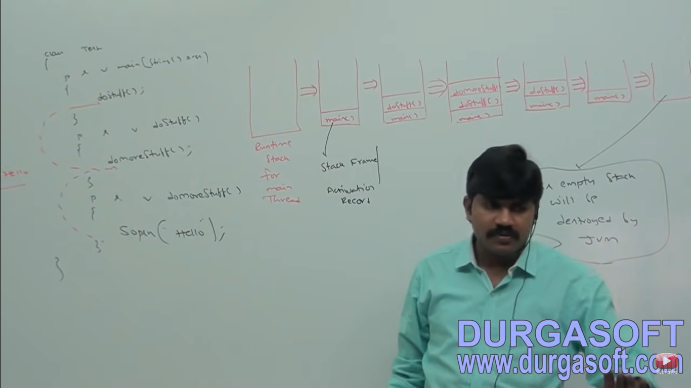

**Default Exception Handling**

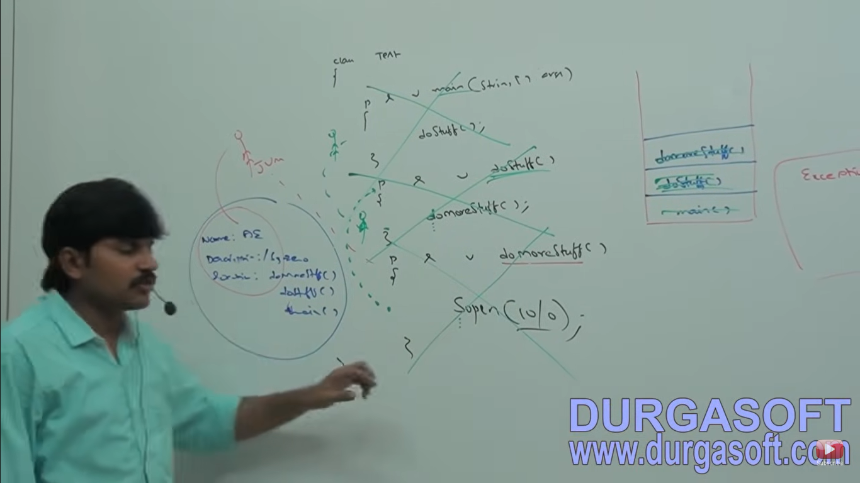

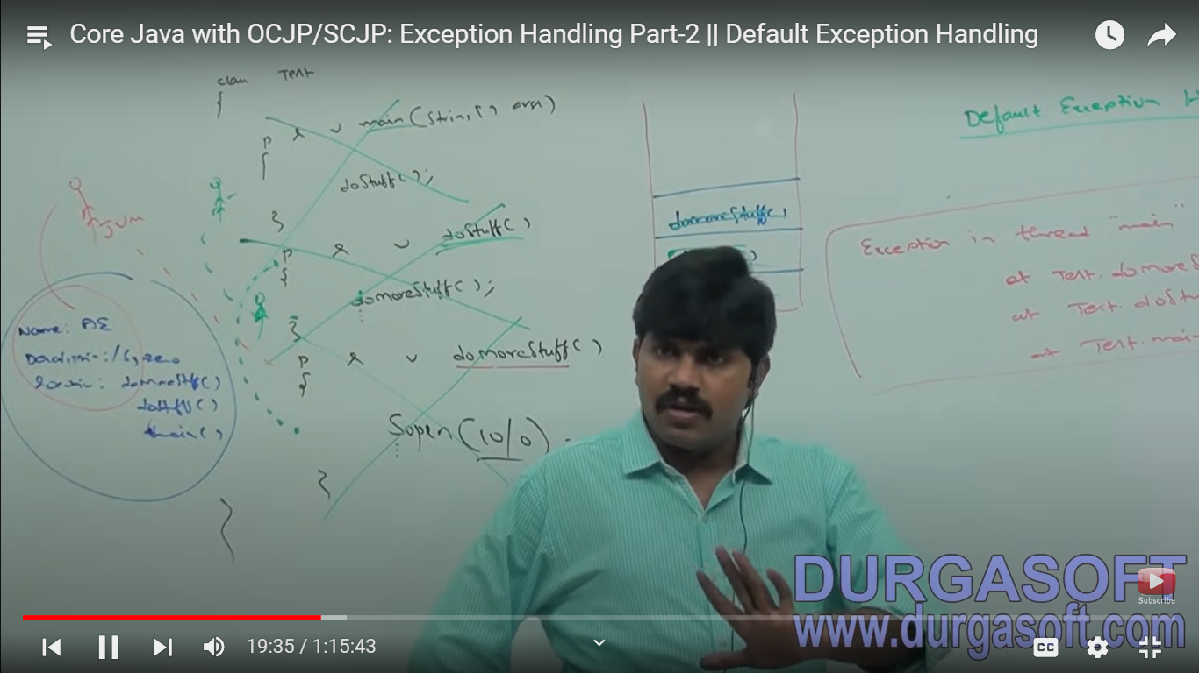

Inside a method if any exception occurs the method in which it is raised JVM is responsible to create exception object by including the following information :

1. Name of Exception
2. Description of Exception
3. Location at which exception occurs (Stack Trace)

JVM will check whether the method contains any exception handling code or not. If the method doesn’t contains exception handling code then JVM terminates that method abnormally and removes the corresponding entry from the stack. JVM identifies caller method and checks whether caller method contains any handling code or not. If the caller method doesn’t handling code then JVM terminates that caller method also normally and removes the corresponding entry from the stack. This process will continued until main method and if the main method also doesn’t contains handling code then JVM terminates main() method also abnormally and removes corresponding entry from the stack. JVM handovers the responsibility of exception handling to default exception handler which is the part of JVM. Default exception handler prints exception information in the following format and terminates program abnormally.

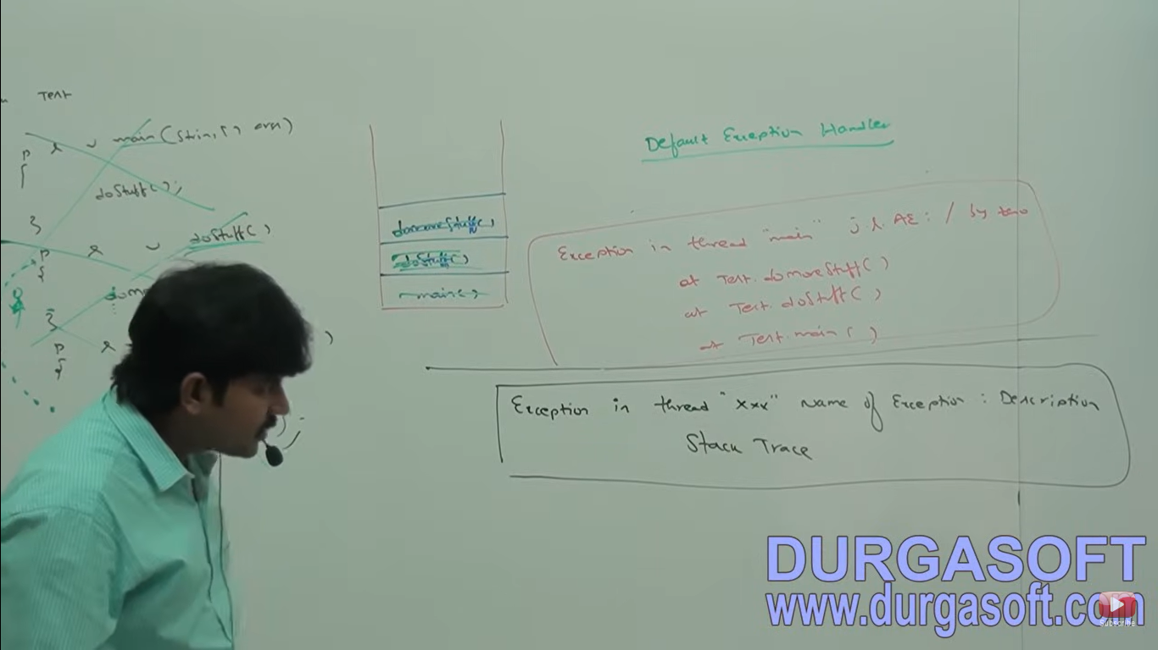

Ex 2:

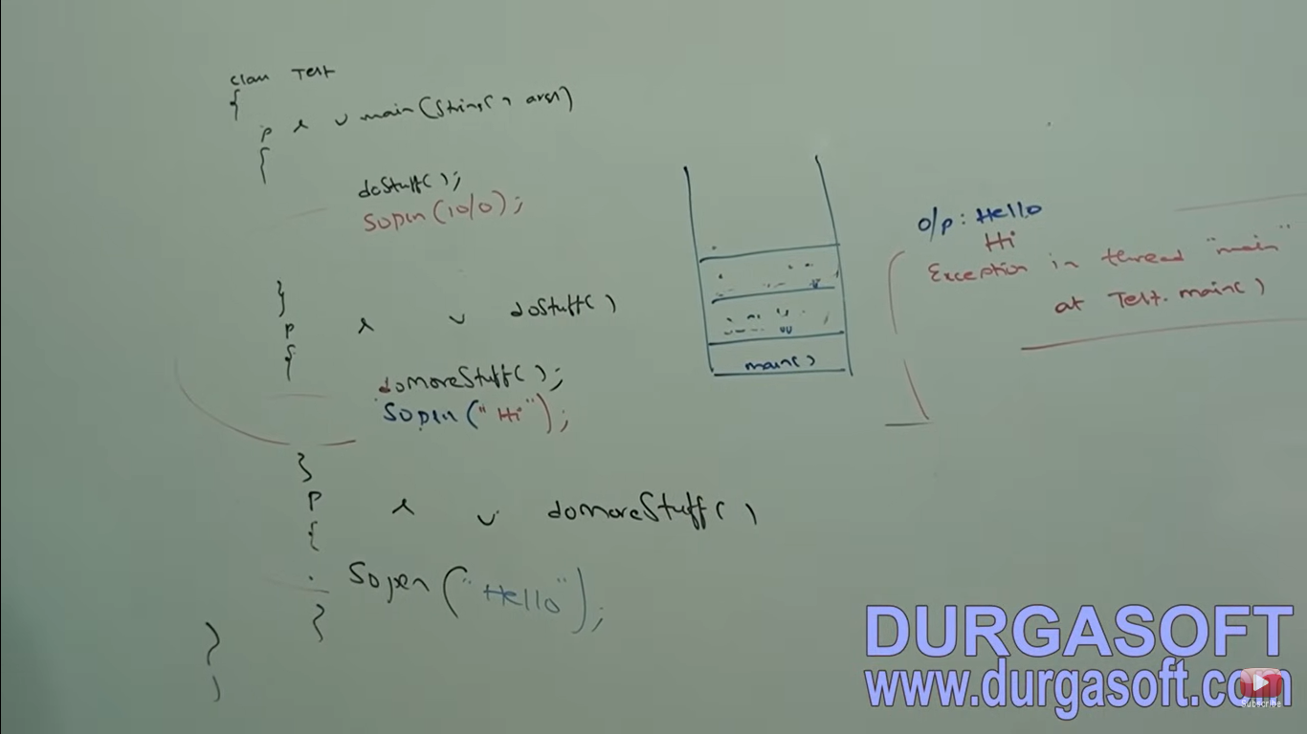

Note – In a program if atleast one method terminates abnormally then the program termination is abnormal termination. If all methods terminated normally then only program termination is normal termination.

**Exception Hierarchy**

For Java exception hierarchy throwable class defines two child classes

1. Exception
2. Error

**Exception**

Exception occurred by our program. Exception is recoverable, For eg if fileNotFoundException occurs then provide local file and continue the program normally.

Most of the time exceptions are caused by our program and these are recoverable for eg if our programming requirement is to read the data from remote file locating at London at runtime if remote file is not available then we will get runtime exception saying fileNotFoundException. If fileNotFoundException occurs we can provide local file and continue rest of the program normally.

Error

Errors are not caused by our program. Errors are non-recoverable. They occur due to lack of system resources. For eg stack overflow or out of memory error occurs.

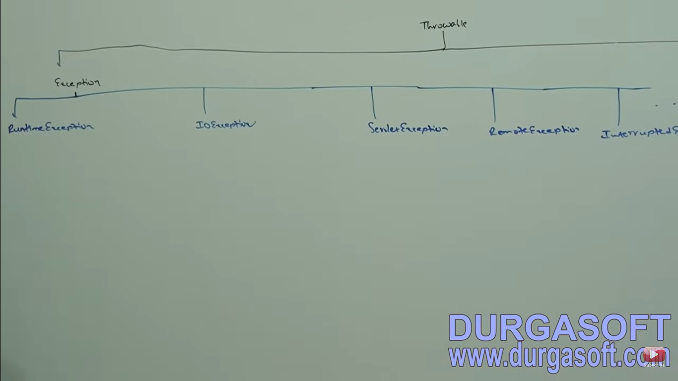

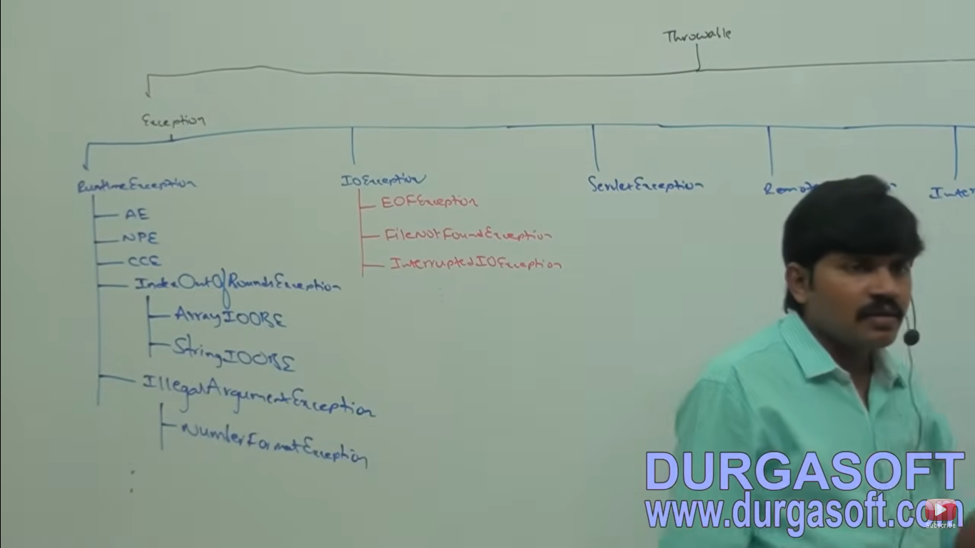

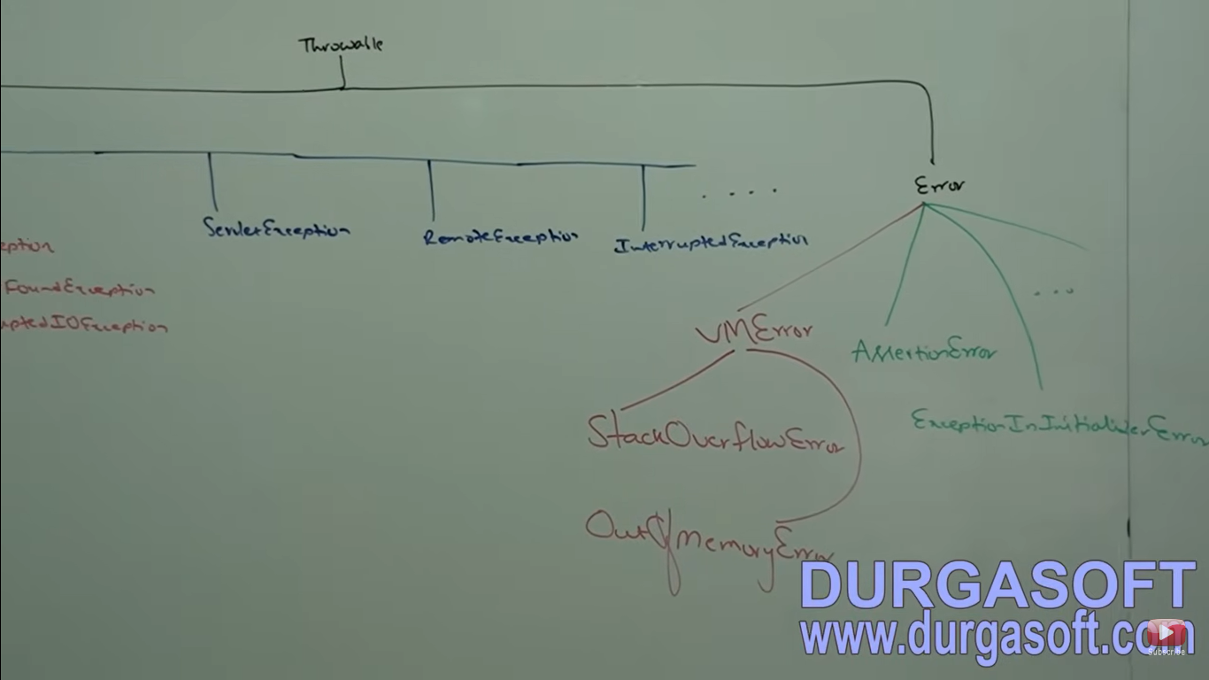

**Checked and Unchecked Exception**

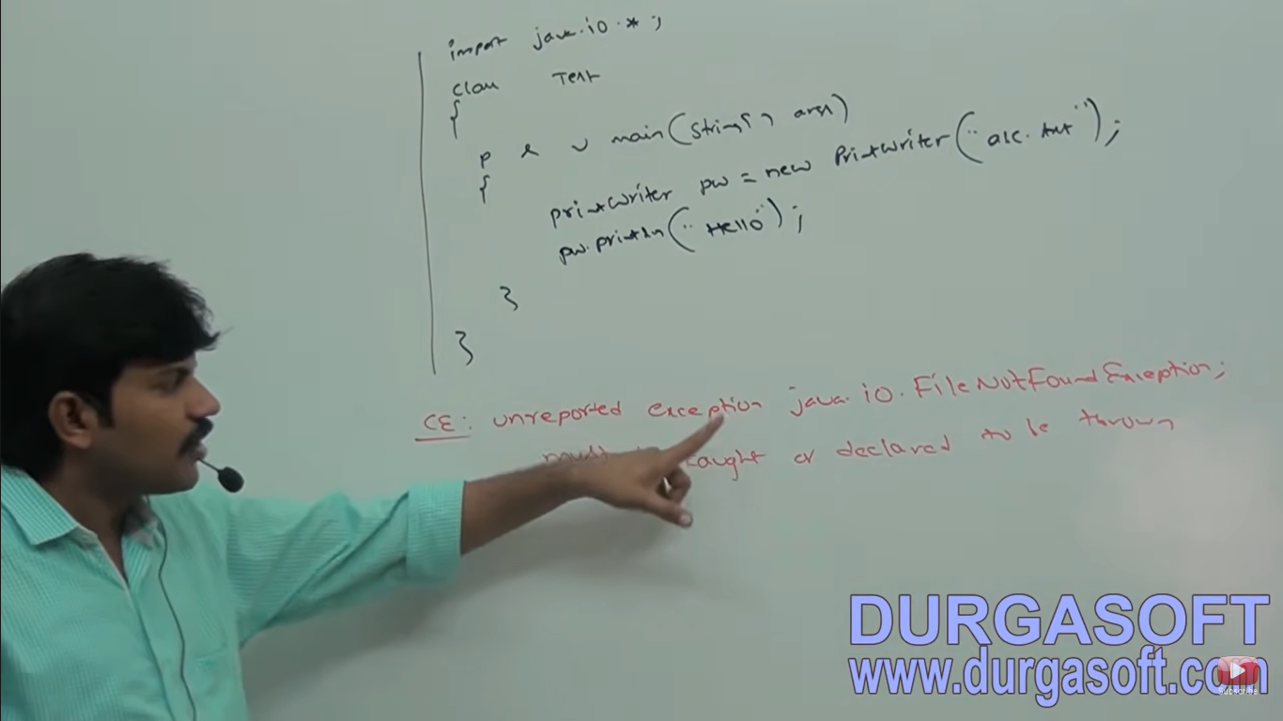

**Checked or Compile Time Exception**

The exception which are checked by compiler for execution of the program are called compile time or checked exception. Then compulsory we should handle that checked exception (Either by try-catch or by throws keyword) otherwise we will get compile time error.

Eg for Checked Exception. FileNotFoundException, Servlet Exception, RemoteException, SQL Exception

**Unchecked Exception**

The exception which are not checked by compiler whether programmer handling or not such types of exceptions are called unchecked exceptions.

Eg. ArithematicException

1. Every exception occurs at runtime only there is no chance of occurring any exception at compile time.
2. Runtime exception and it’s child classes, error and it’s child classes are unchecked except these remaining are checked.

**Fully Checked vs Partially checked**

A checked exception is said to be fully checked if only if all it’s child classes also are checked. Eg. IOException, Interrupted Exception

A checked exception is said to be partially checked if only if it’s some of it’s child classes are unchecked. Eg; Exception, throwable.

Note – The only possible partially checked exception in java are:

1. Exception
2. Throwable

**Describe the behavior of following exceptions?**

IOException – checked (Fully)

RuntimeException – Unchecked

InterruptedException – Checked (Fully)

Error – Unchecked

Throwable – Partially Checked

Arithematic Exception – Unchecked

NullPointerException - Unchecked

Exception – Partially Checked

FileNotFoundException – Checked (Fully)

**Customized Exception Handling By using try-catch**

It is highly recommended to handle exception the code which may rise an exception is called risky code and we have to define that code inside try block and corresponding handling code we have to define inside catch block.

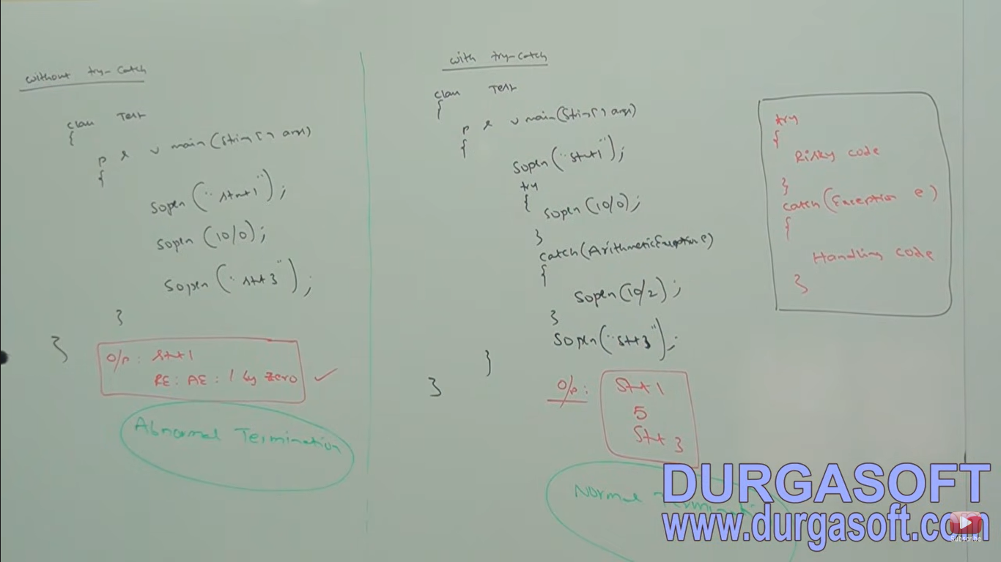

**Case 1: If there is no exception**

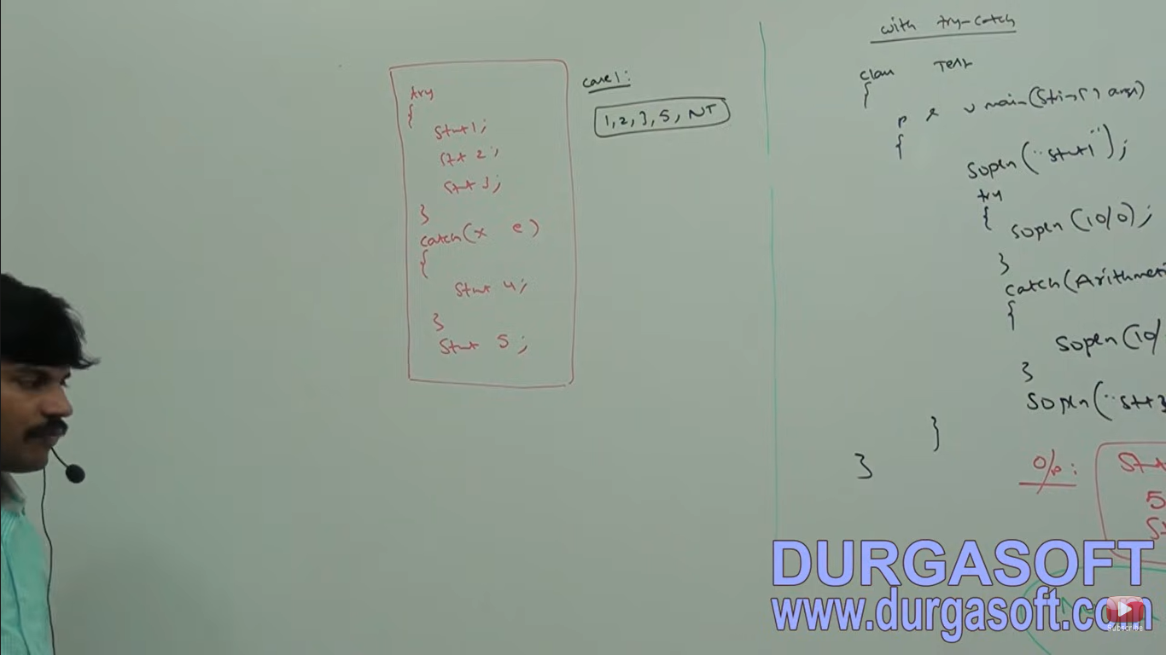

1,2,3,5 normal termination

**Case 2: If an exception rise in statement 2 and corresponding catch block matched.**

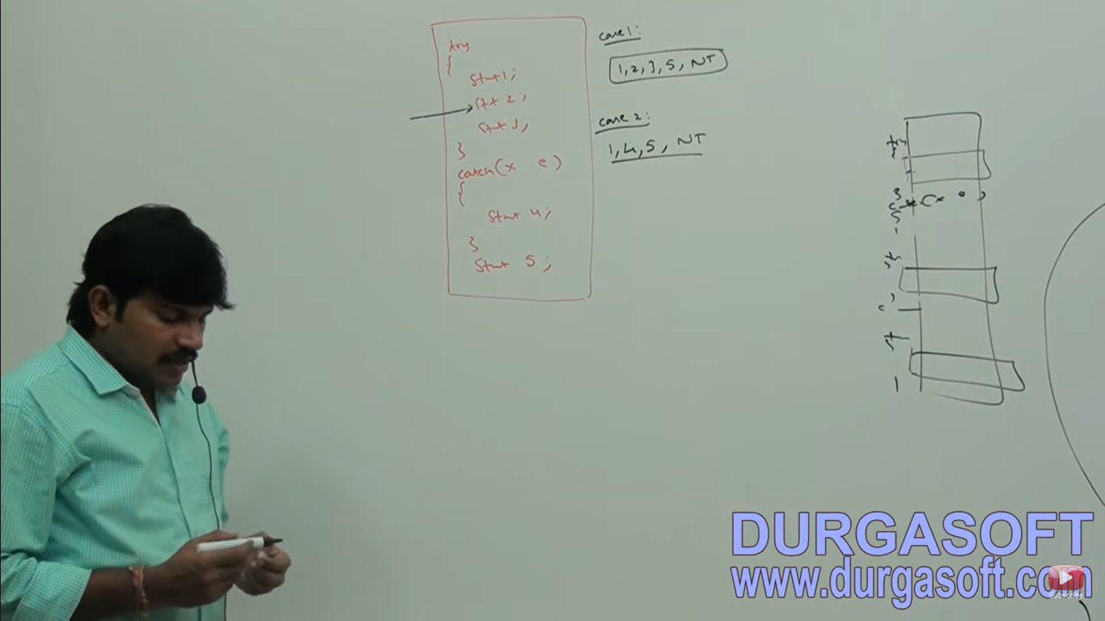

1,4,5 – Normal termination**Case 3: If an exception rise at statement 2 and corresponding catch block not matched**

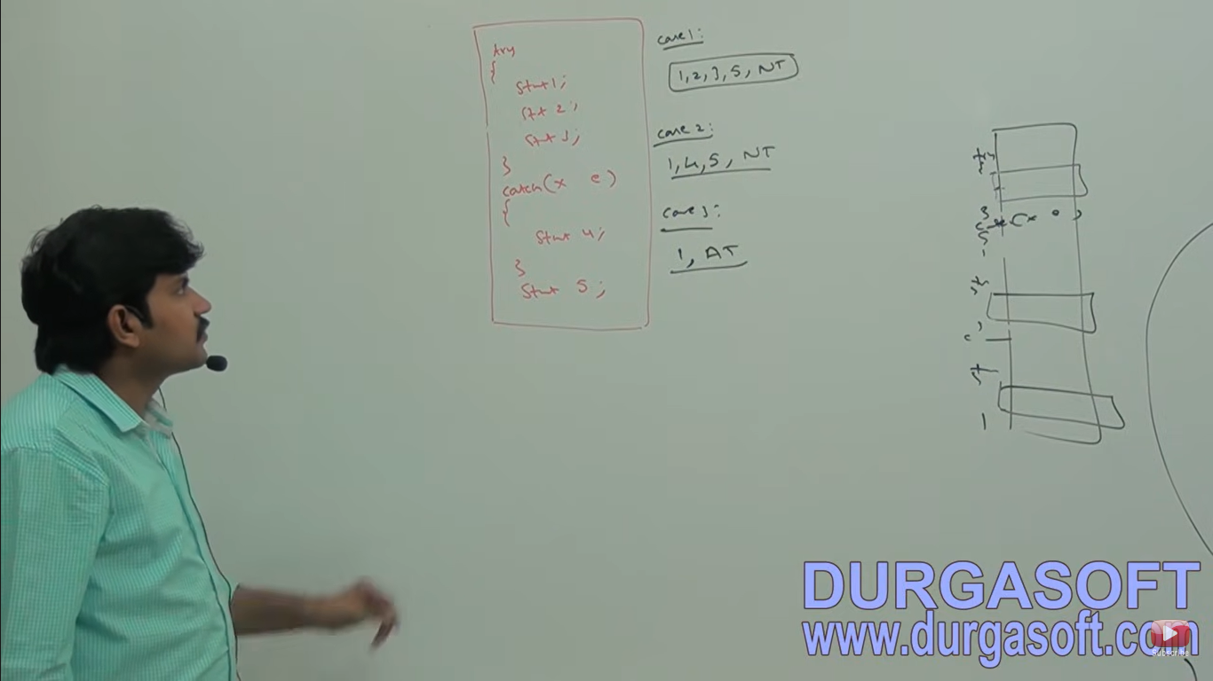

1, Abnormal Termination

**Case: If an exception rise at statement 4 or statement 5 then it is always abnormal termination**

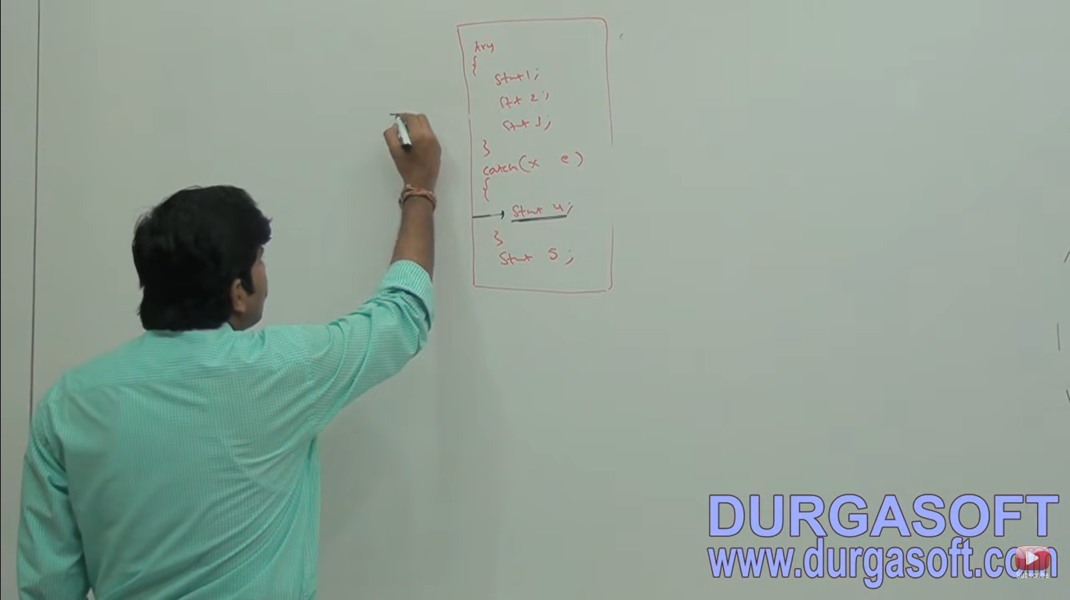

**Note – Within the try block if anywhere an exception rise then rest of the try block won’t be executed even though we handled that exception, within the try block we need to take risky code and the length of try block should be as less as possible.**

**In addition to try block there may be a chance of rising an exception inside catch and finally blocks**

**If any statement which rises an exception and it is not part of try block and rises an exception then it is always abnormal termination.**

**Methods to print Exception Information**

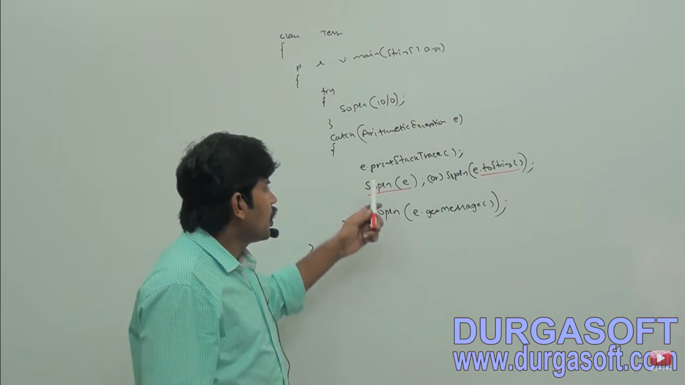

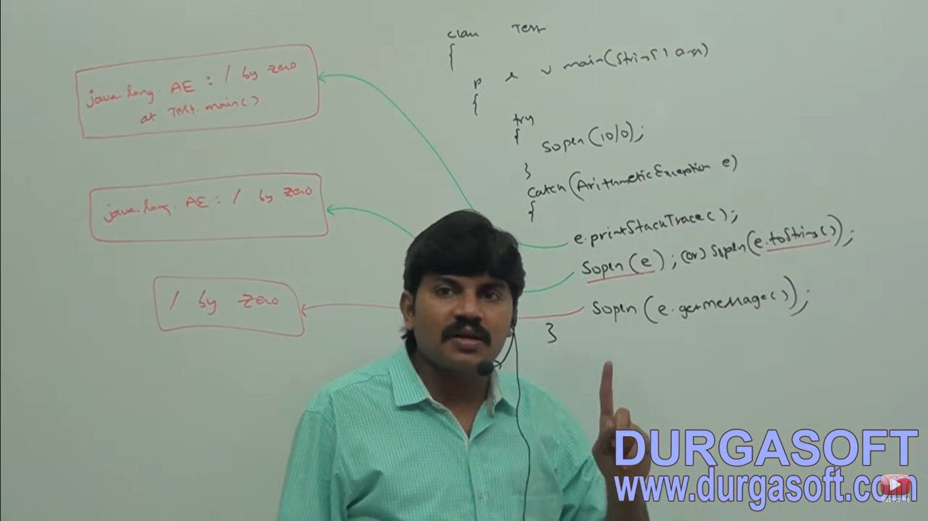

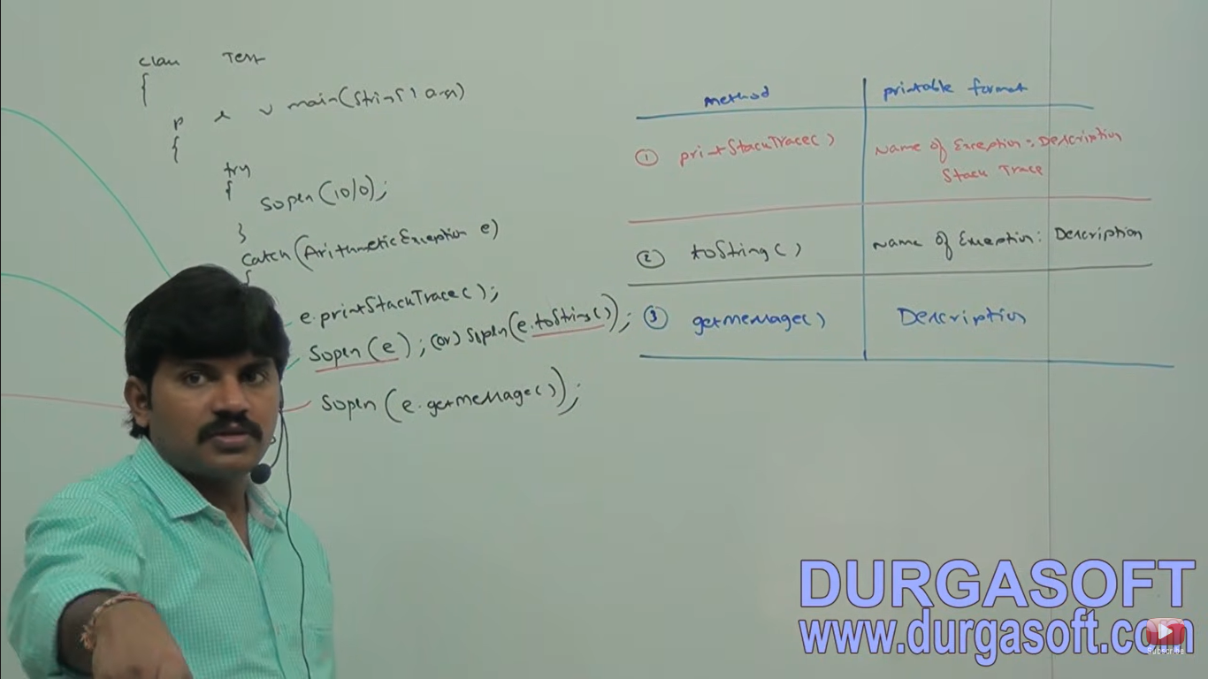

Throwable class defines the following methods to print the exception information

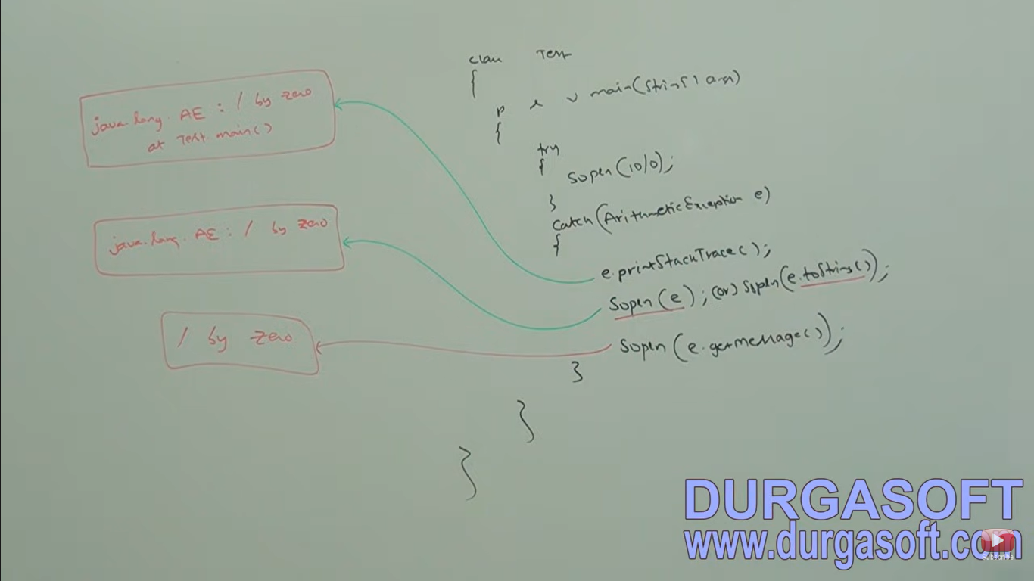

**Ways of handling Exception**

The way of handling an exception is varied from exception to exception hence for every exception type it is highly recommended to take separate catch block that is try-with-multiple catch blocks is always possible and recommended to use.

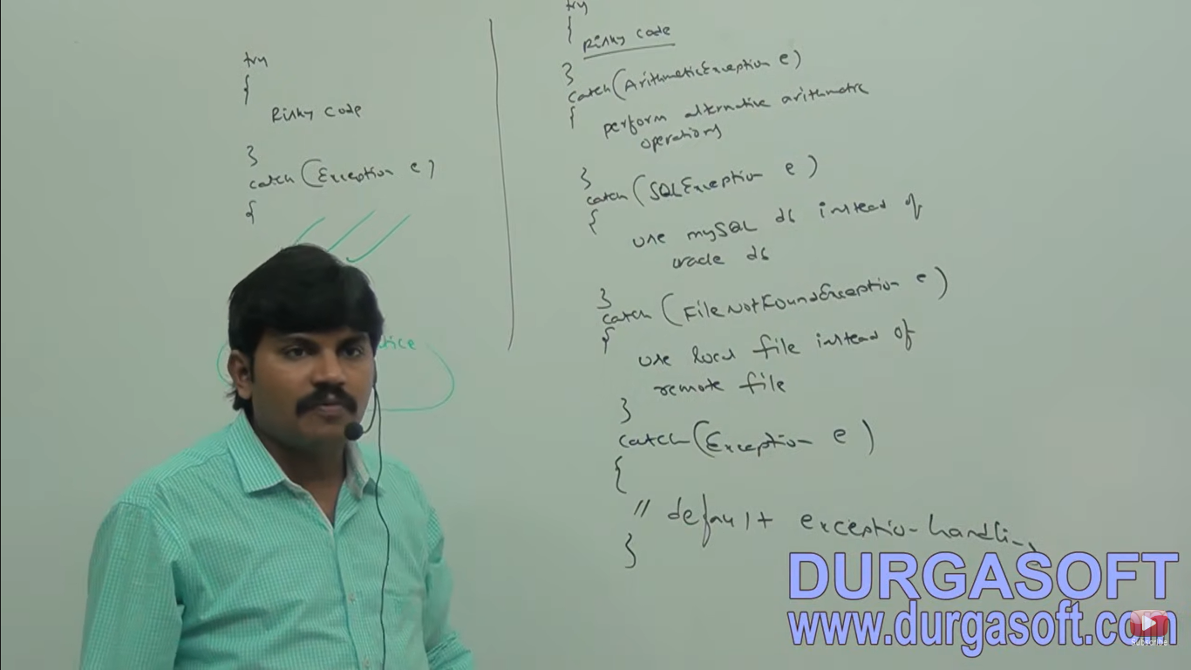

**Valid/Invalid Catch block Declaration**

If try-with multiple catch blocks present then the order of catch blocks is very important. We have to take child first and then parent otherwise we will get compile time error saying Exception xxx has already been caught

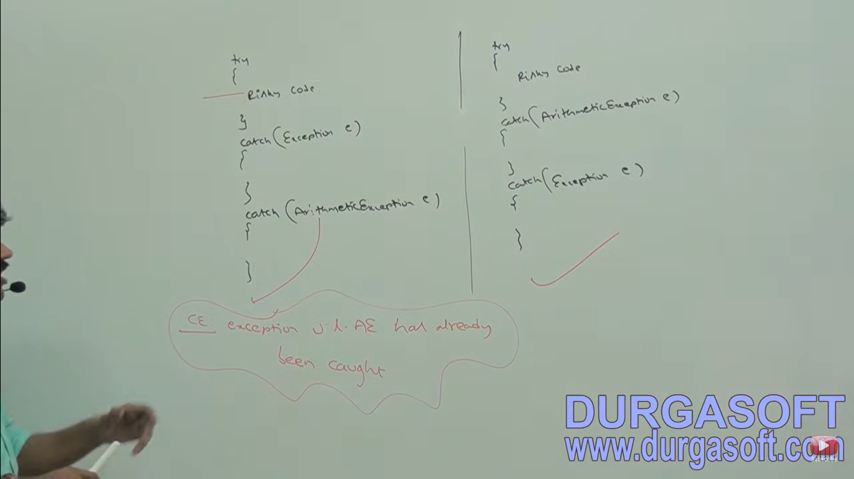

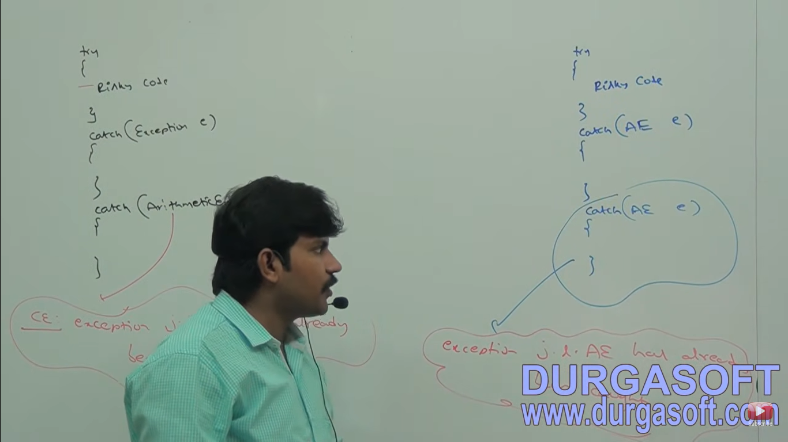

**Final**

Final is the modifier applicable for classes methods and variables. If a class declared as final then we can’t extend that class that is we can’t create child class for that class that is inheritance is not possible for final classes.

If a method is final then we can’t override that method in the child class

If a variable declared as final then we can’t perform reassignment for that variable.

**finally**

finally is always associated with try-catch to maintain cleanup code

try{

Risky code

}catch(Exception e){

Handling code

}finally{

Cleanup code

}

The specialty of finally block is it will be executed always irrespective of whether exception is raised or not raised and whether handled or not handled.

**finalize()**

finalize() is a method always invoked by System.gc(); (garbage collector) just by before destroying an object to perform cleanup activities. Once finalize() method completes immediately garbage collector destroys that object.

Scenarios:

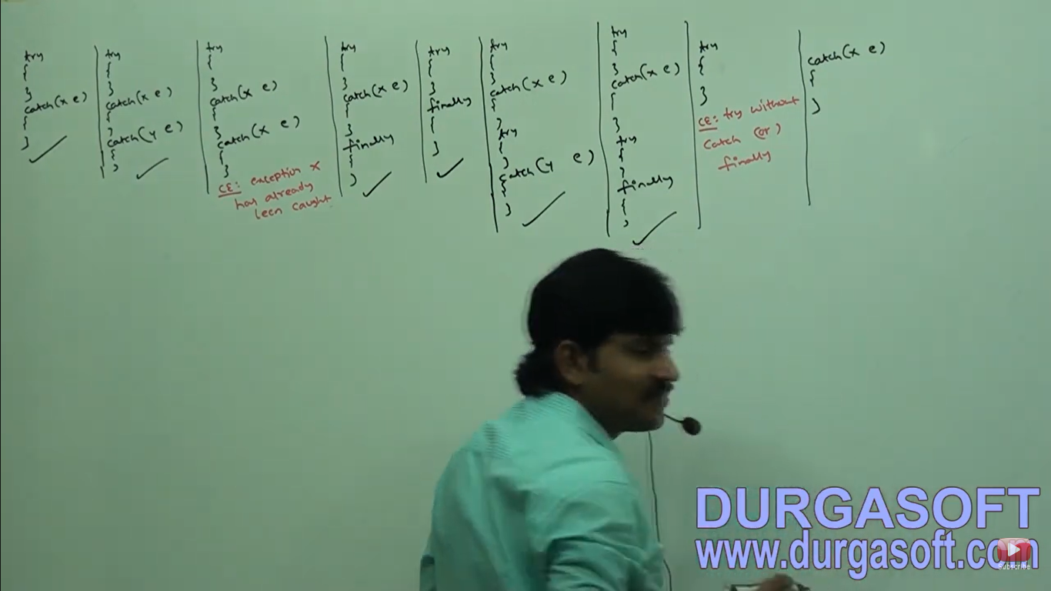

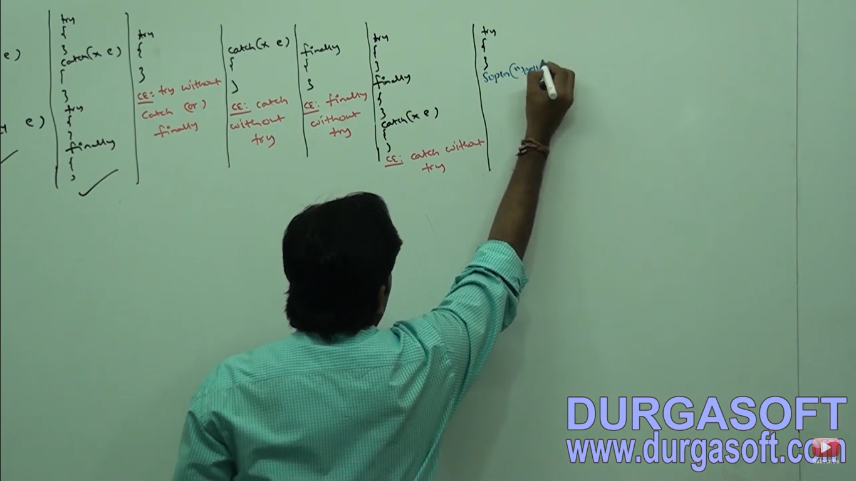

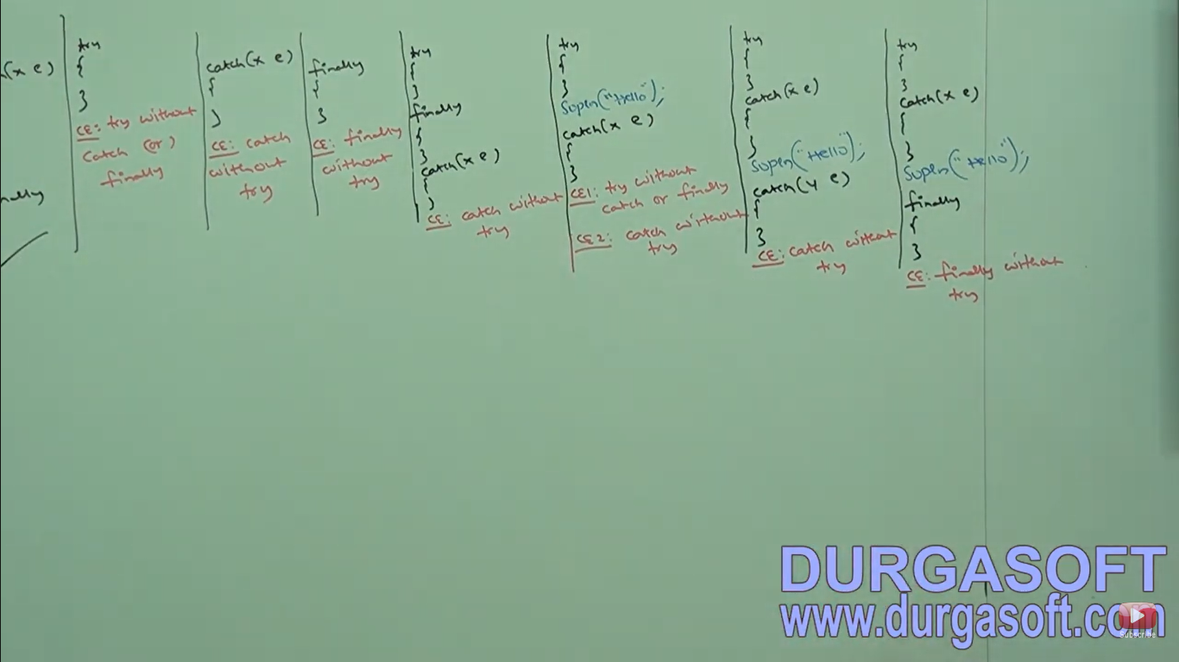

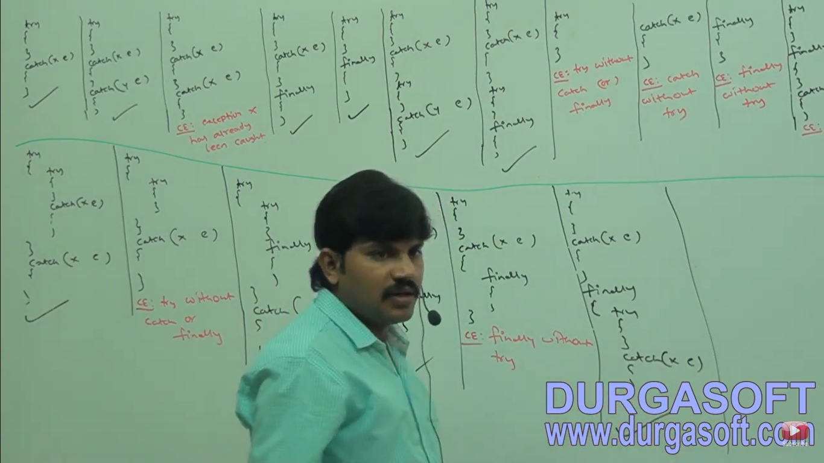

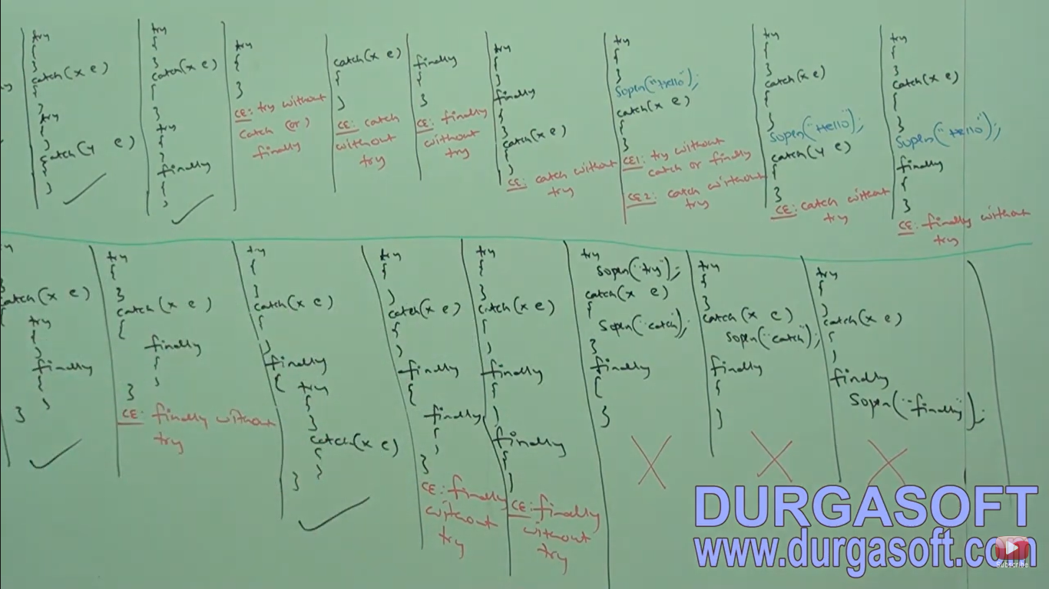

**Conclusions:**

1. In try-catch-finally order is important
2. Whenever we are writing try compulsory we should write either catch or finally. Otherwise we will get compile time error. That is try without catch or finally is invalid.
3. Whenever we are writing catch block compulsory try block must be required That is catch without try is invalid.
4. Whenever we are writing finally block compulsory we should write try block that is finally without try is invalid.
5. Inside try and catch finally blocks we can declare try-catch and finally blocks that is nesting of try-catch-finally is allowed.
6. For try-catch and finally blocks curly braces are mandatory.

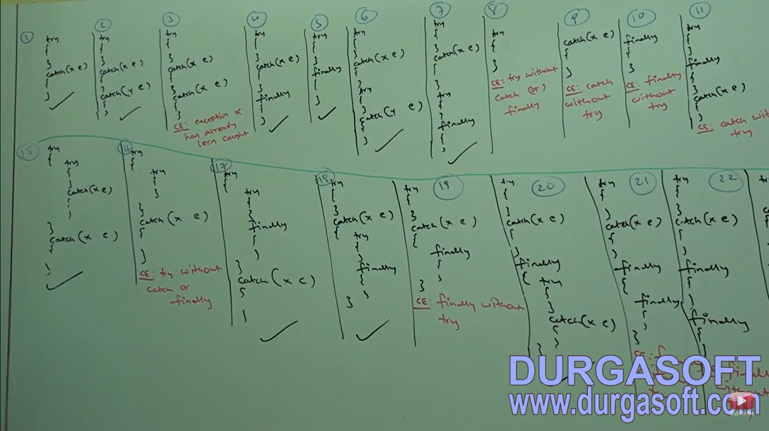

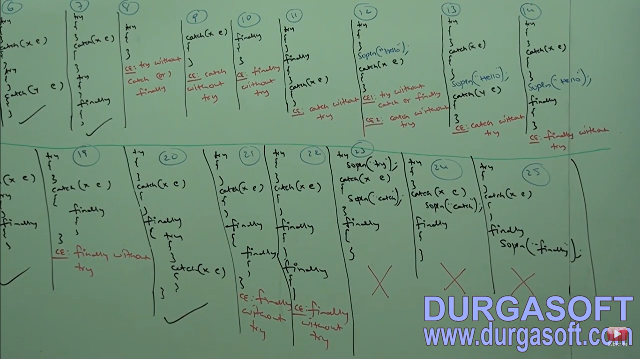

**throw**

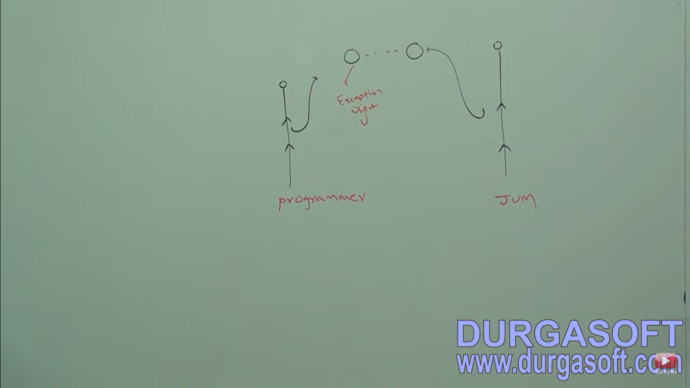

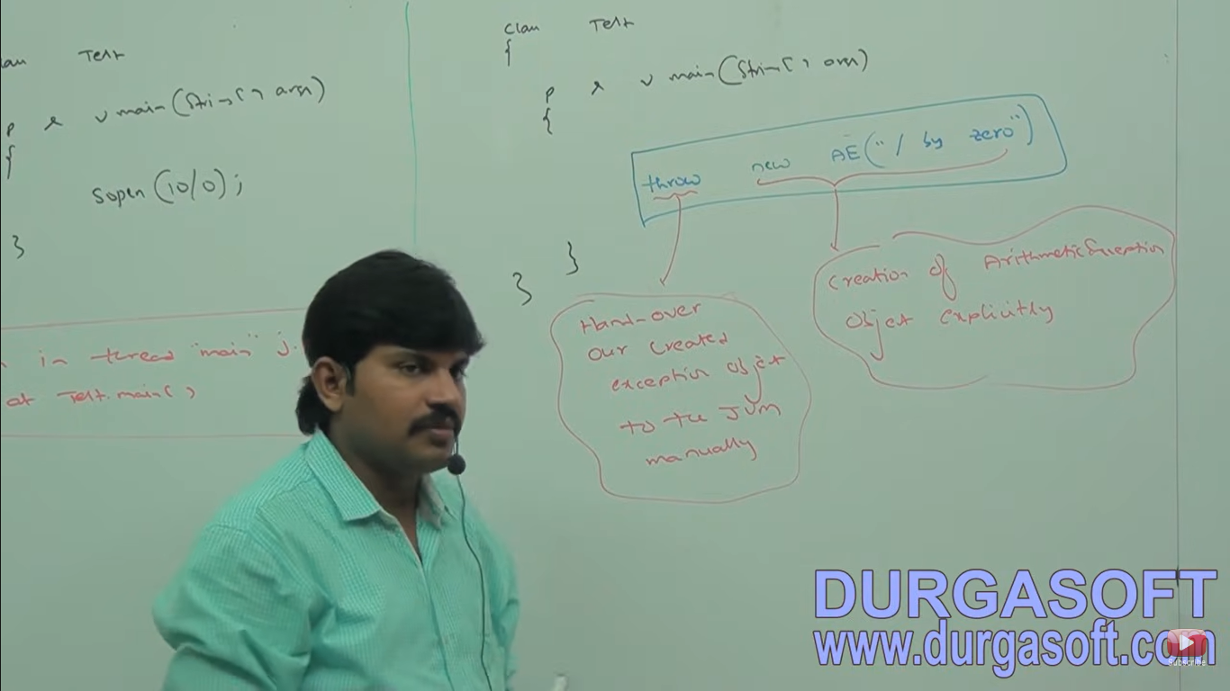

Sometime we can create exception object explicitly, we can handover to the JVM manually. For this we have to use throw keyword.

1 -main() method is responsible for creating exception and handover to the JVM.

2 – In this case programmer is responsible or creating the exception object explicitly and handover to the JVM.

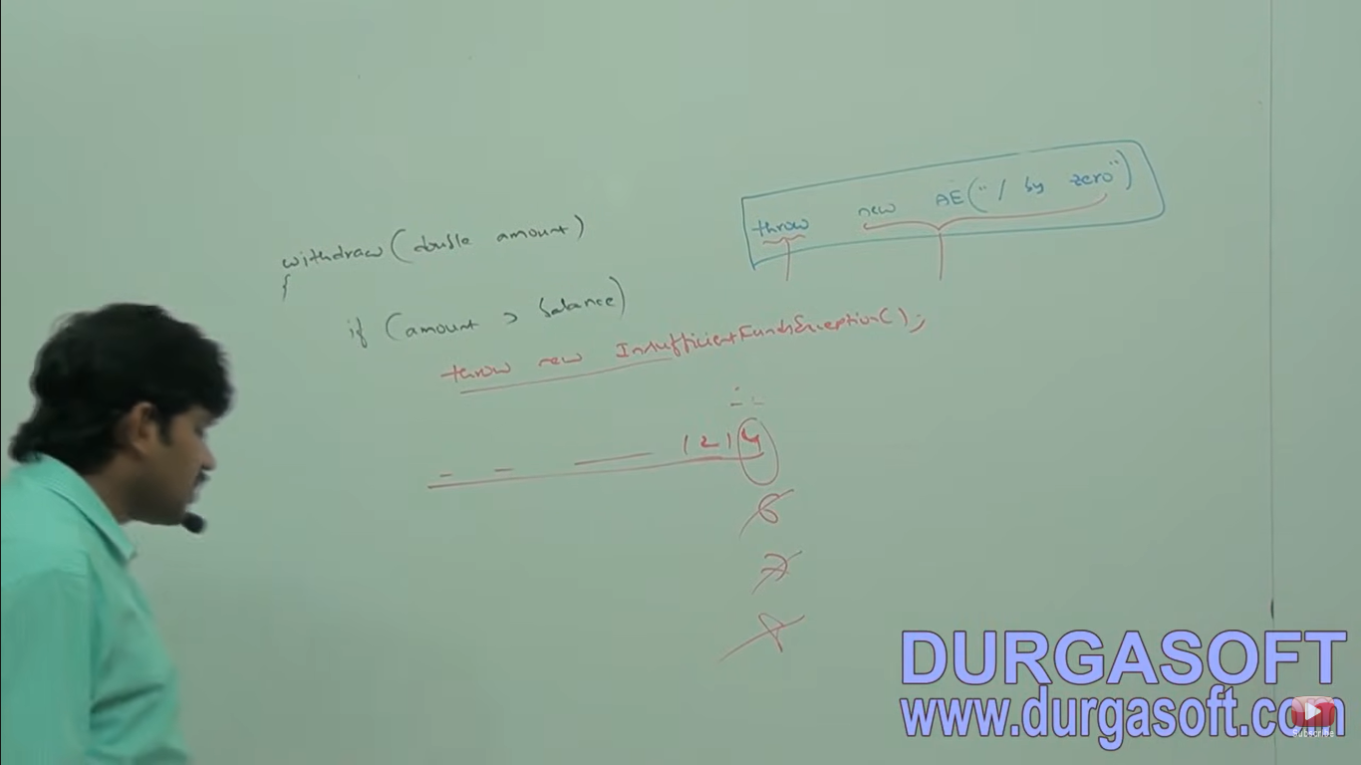

Note - throw best useful for customized exception or user define exceptions.

Case 1: If e refers null then we will get null pointer exception.

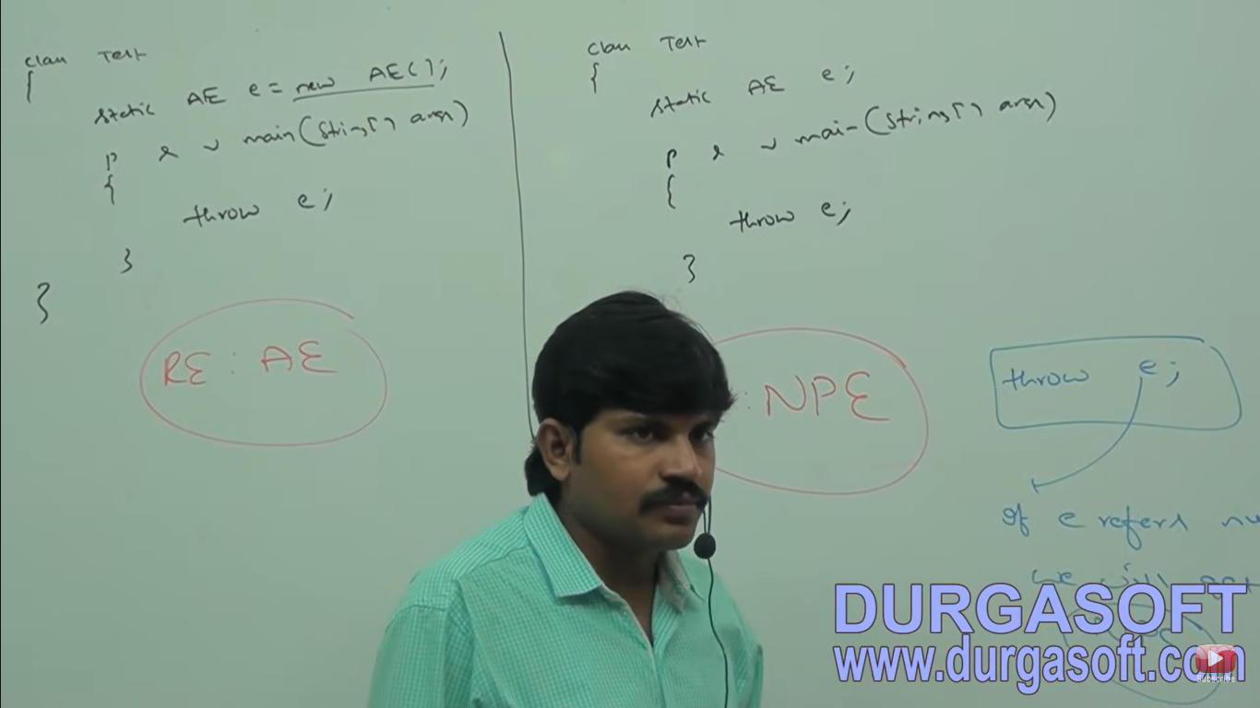

Case 2:

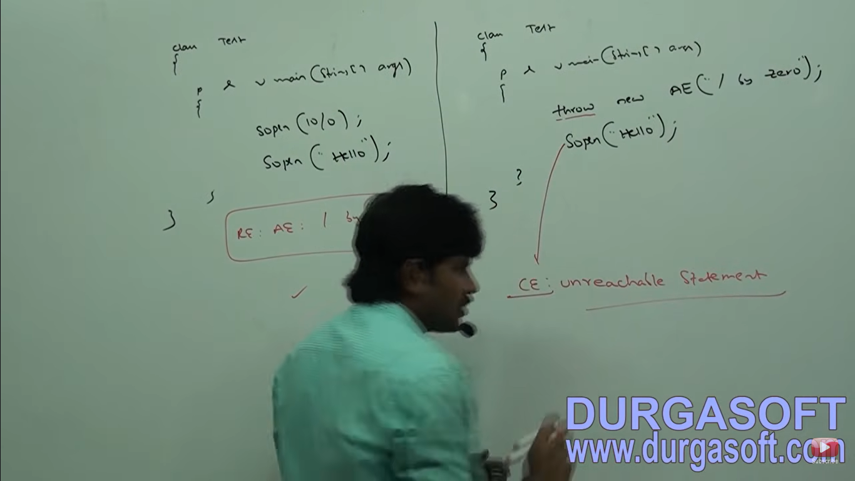

Case 3: We can use throw only for throwable types if we are trying to use for normal Java objects we will get compile time error saying incompatible types found test require java.lang.throwable.

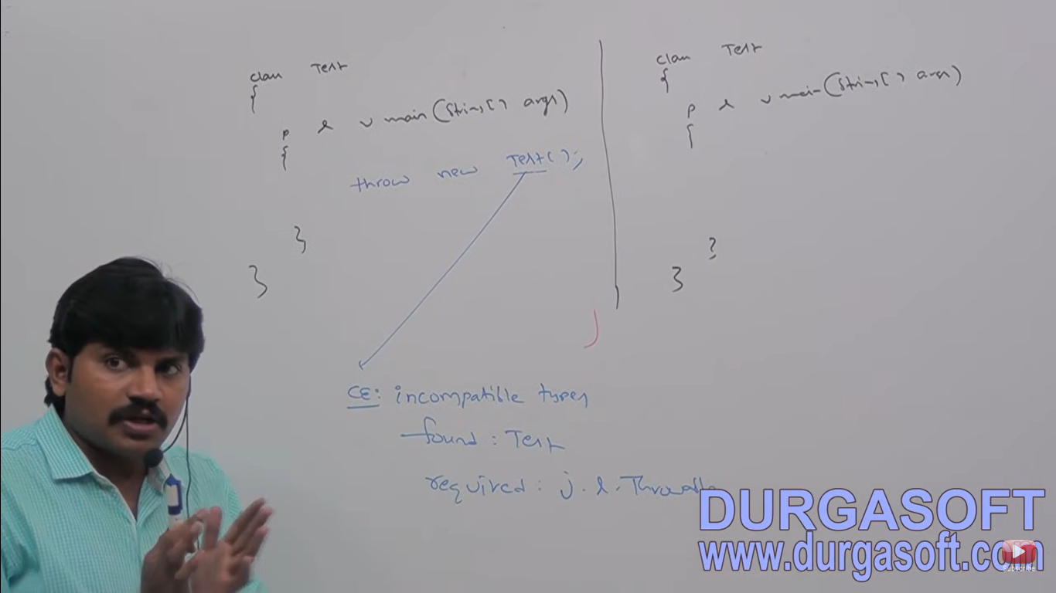

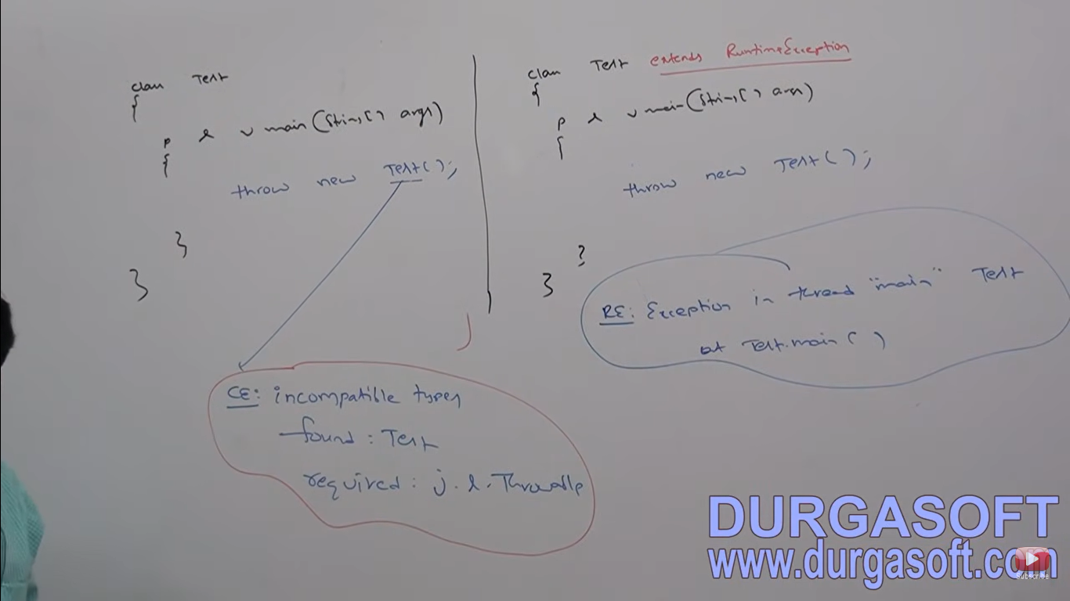

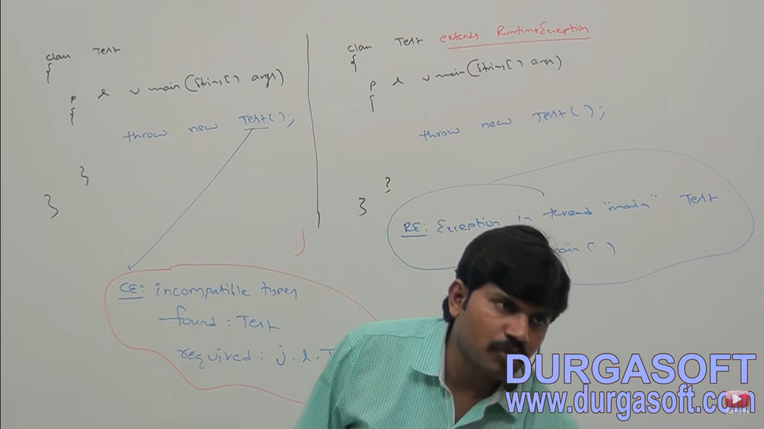

**Throws keyword**

In our program if there is a possibility of raising checked exception then compulsory we should handle that checked exception otherwise we will get compile time error saying **“Unreported exception XXX: must be caught or declared to be thrown”.**

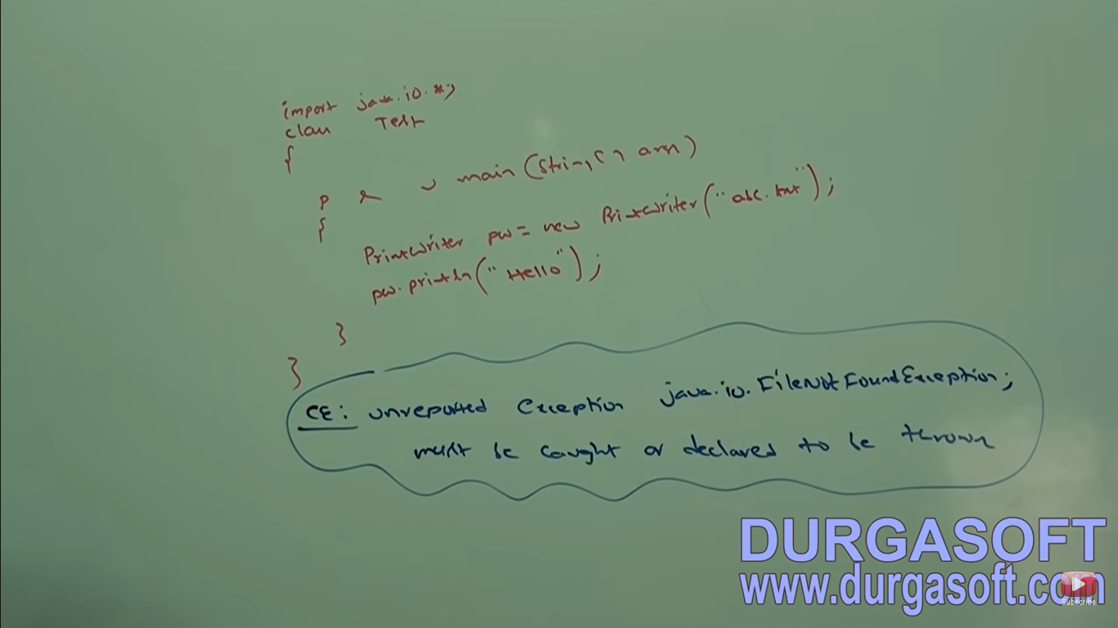

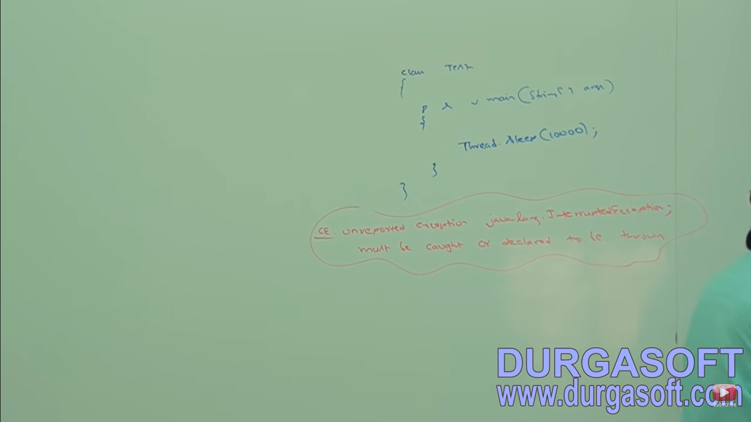

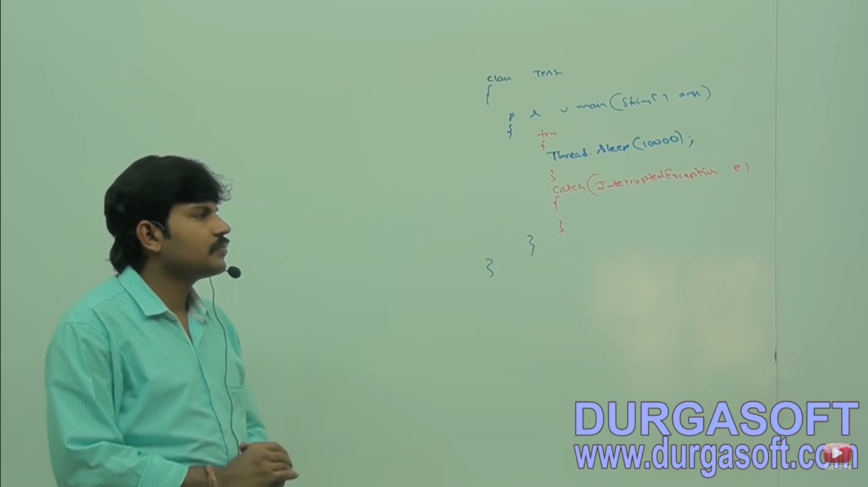

We can use throws keyword to delegate responsibility of exception handling to the caller (it maybe another method or JVM) then caller method is responsible to handle that exception.

Throws keyword only required for checked exception and usage of throws keyword for unchecked exception there is no use or impact. Throws keyword require only to convince compiler and usage of throws keyword doesn’t prevent abnormal termination of the program.

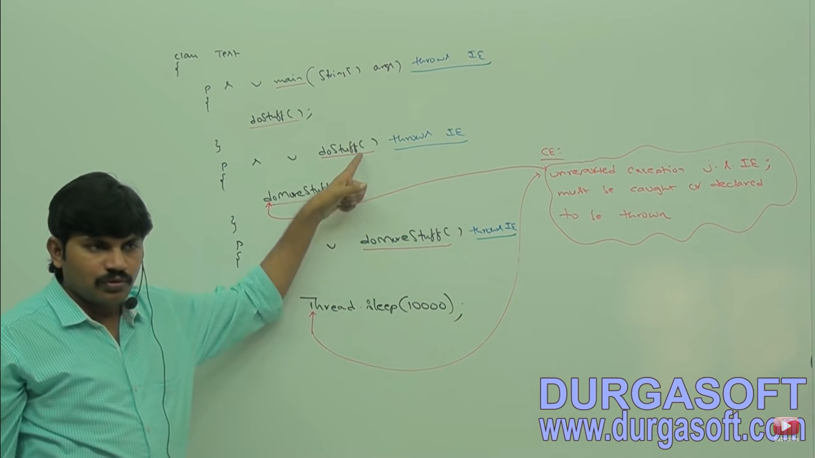

In the above program if we remove atleast one throws statement then the code won’t compile.

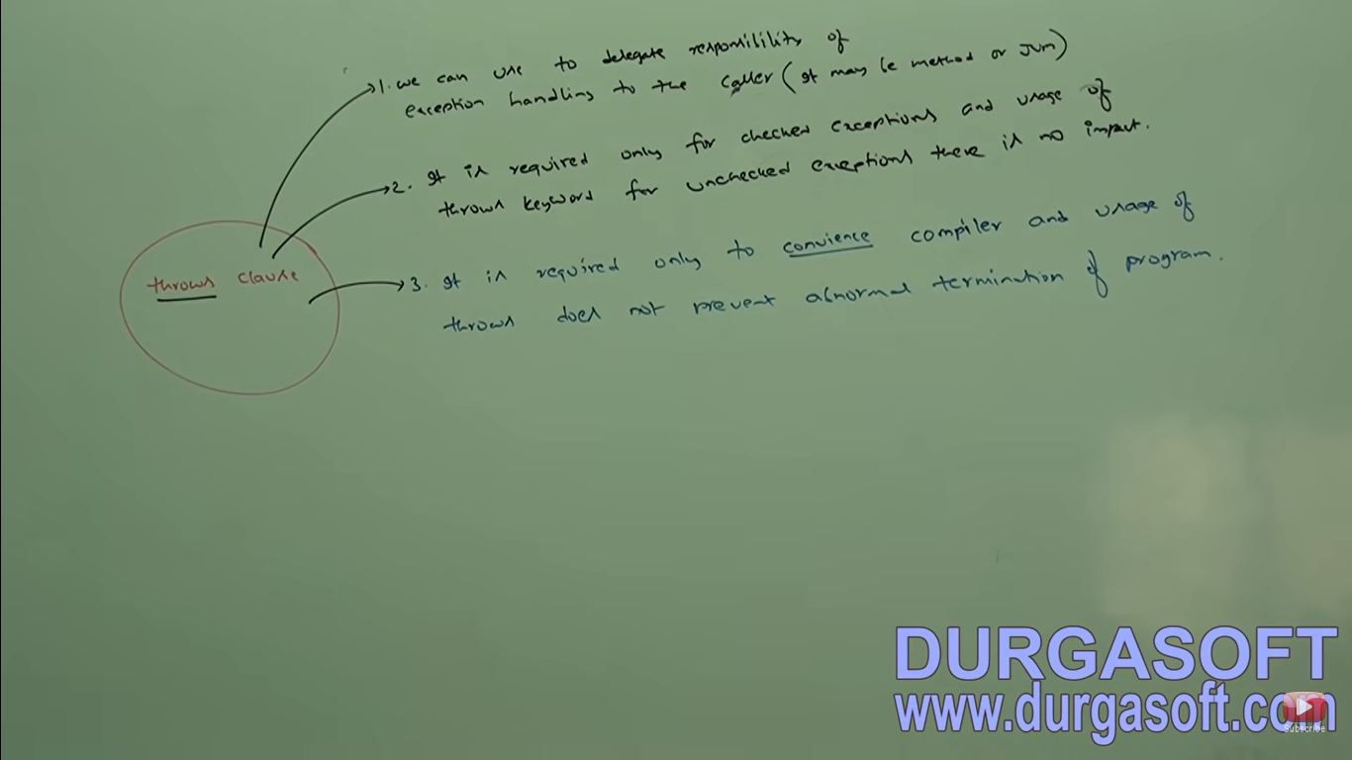

**Case 1: We can use throws keyword for methods and constructors but not for classes**

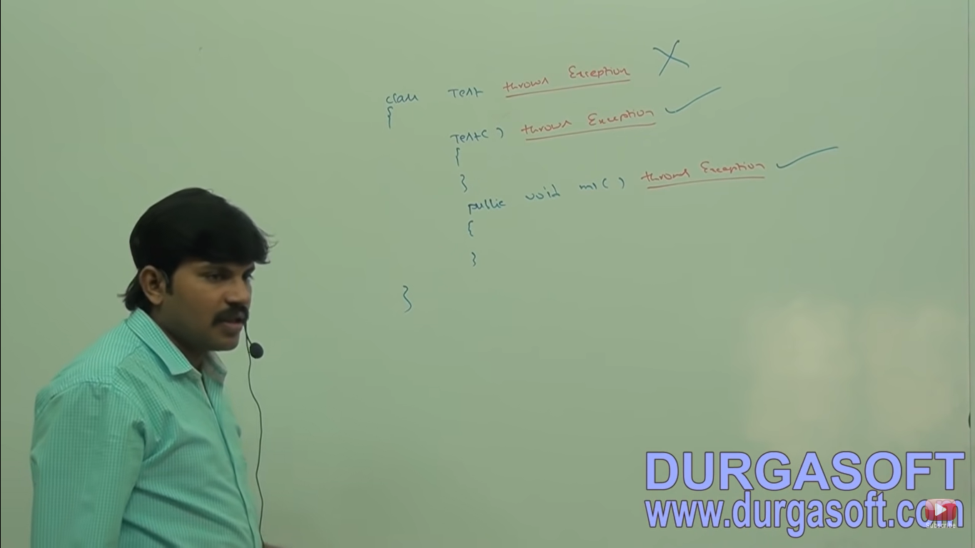

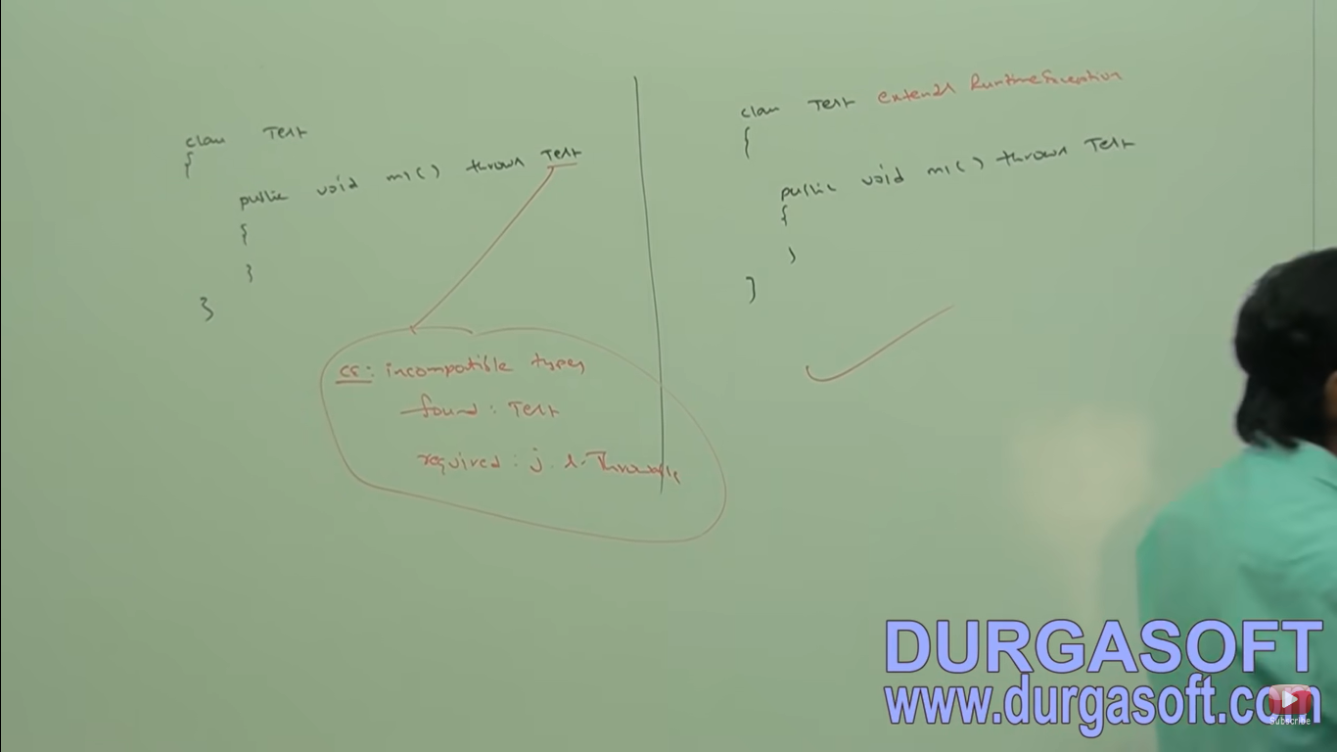

We can use throws keyword only for throwable types, if we are trying to use for normal java classes then we will get compile time error saying “incompatible types found: Test require: java.lang.throwable”

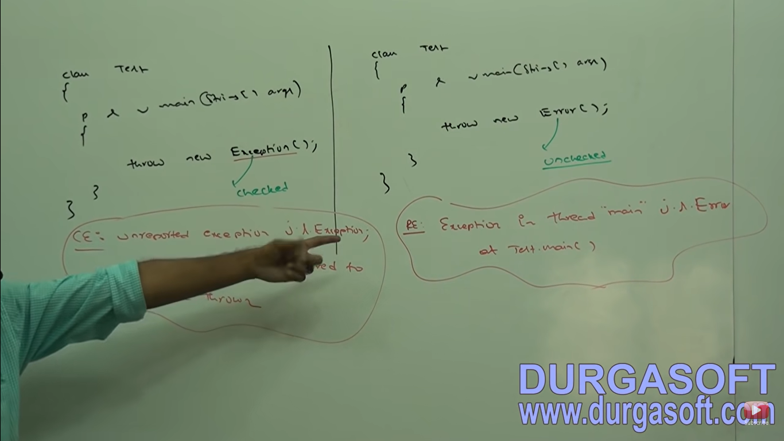

Scenarios:

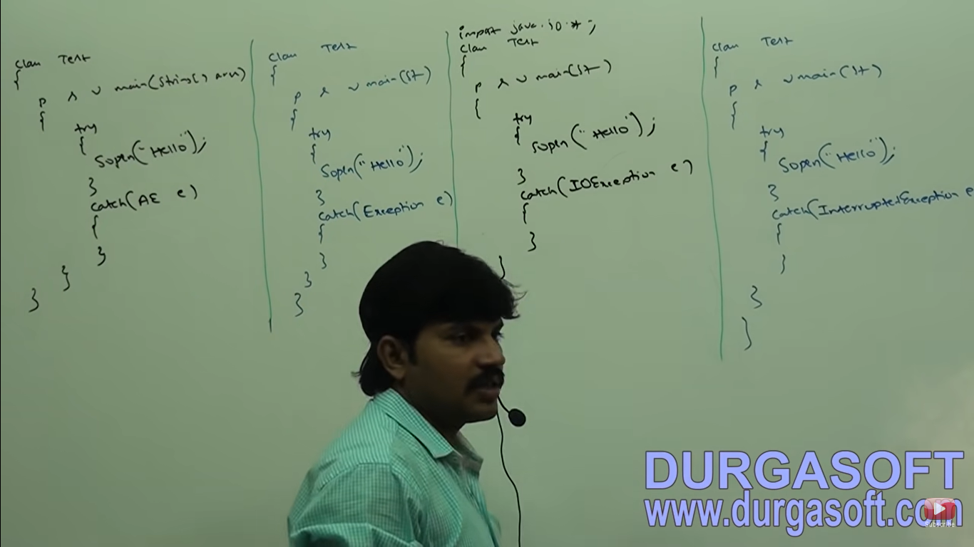

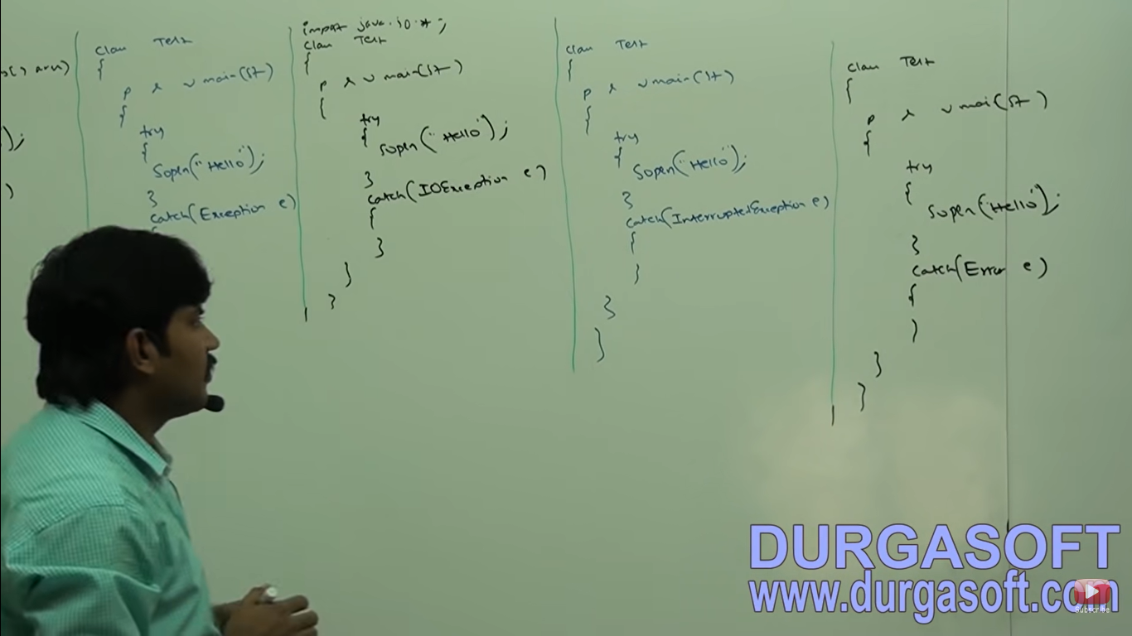

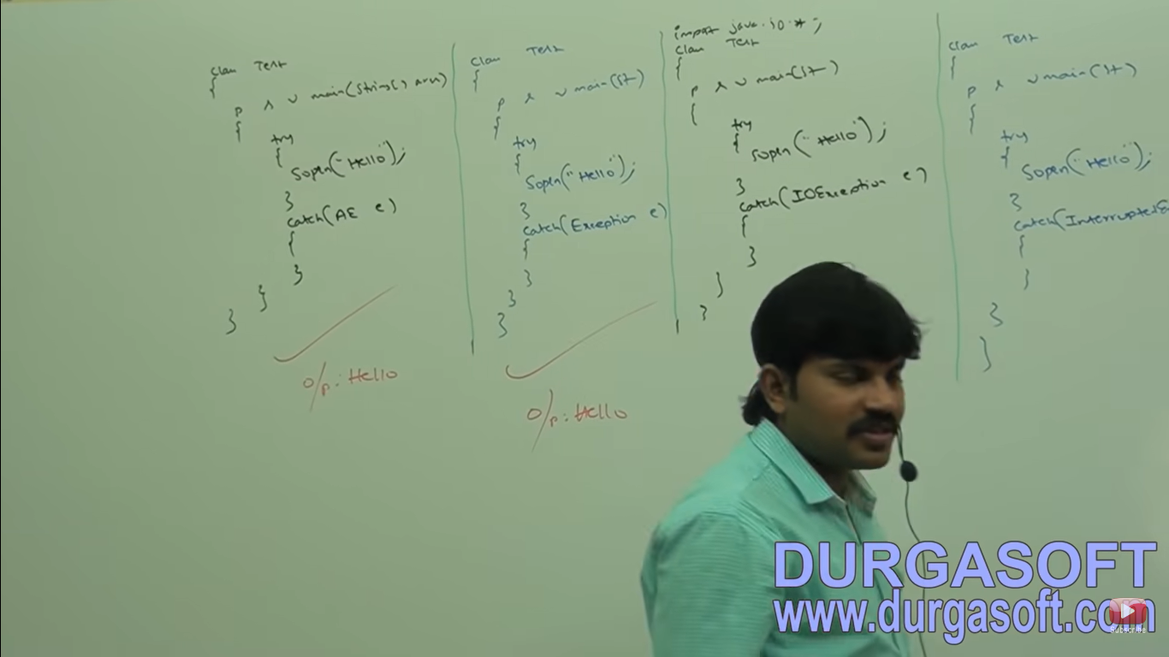

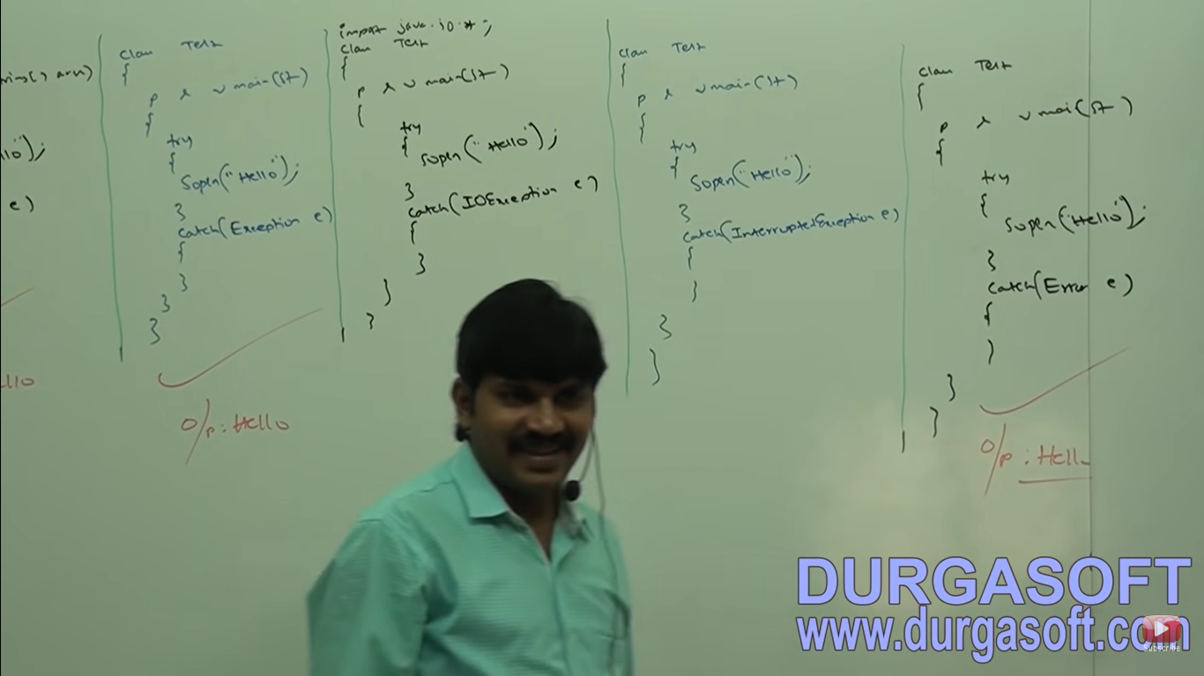

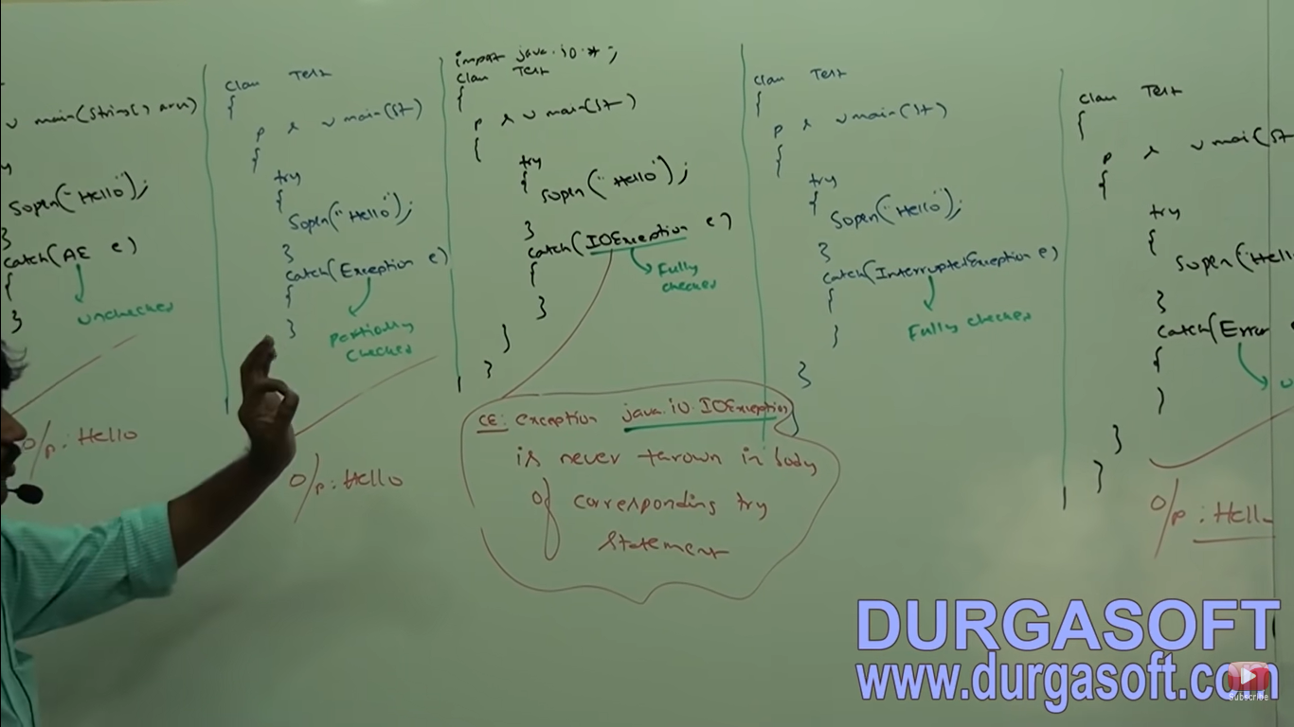

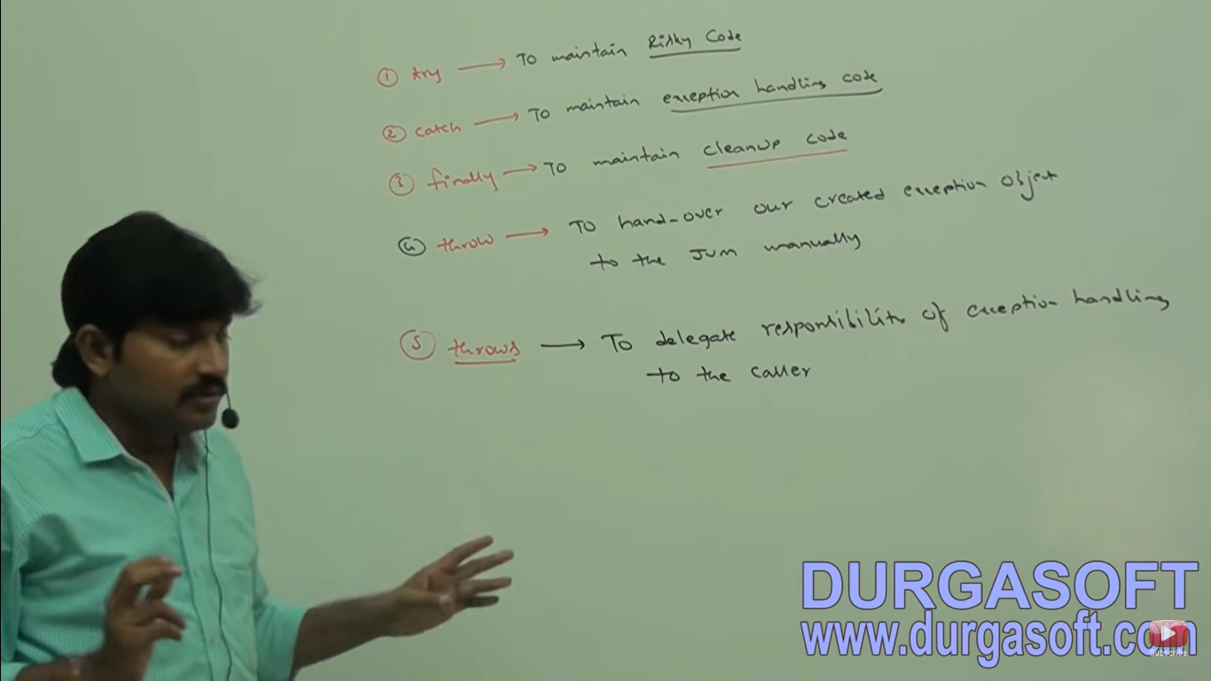

**Customized Exception**

Various possible errors in exception handling

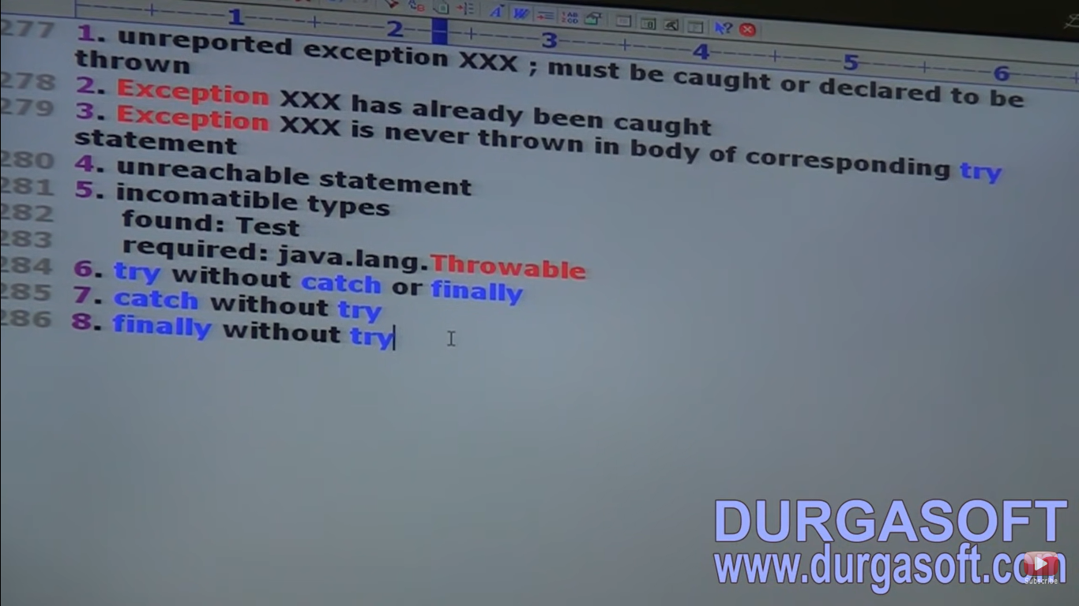

Sometimes to meet programming requirement we can define our own exception such type of exceptions are called Customized exception or user defined exceptions.

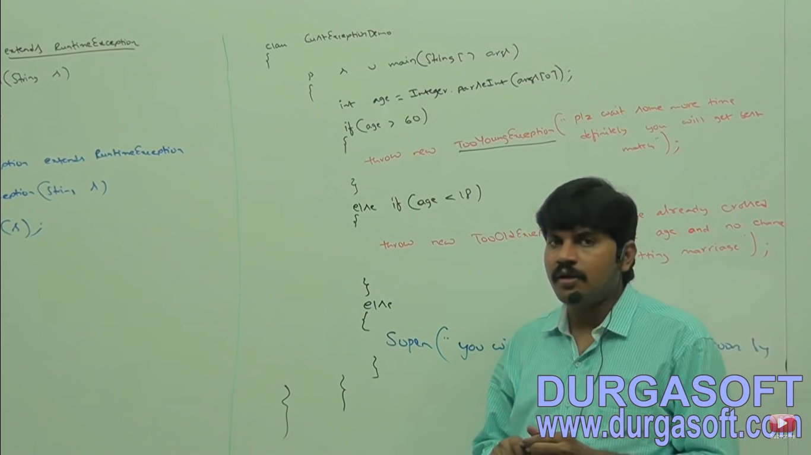

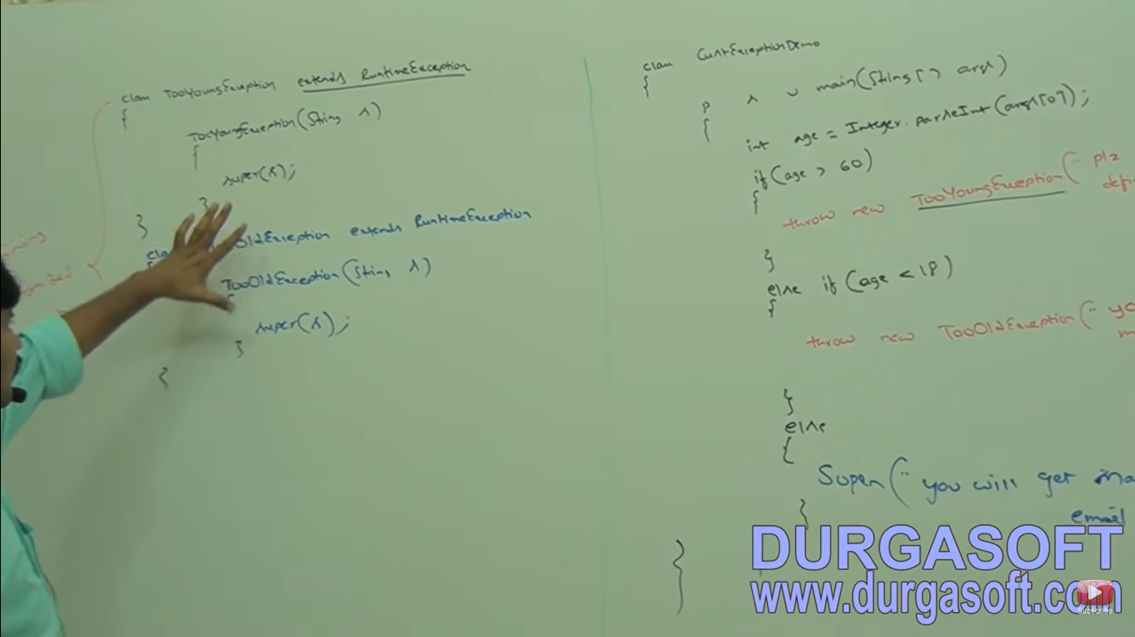

Note – 1. throw keyword is the best suitable for user-defined or customized exceptions but not for pre-defined exceptions.

1. It is highly recommended to define customized exception as unchecked. That is we have to extends RuntimeException but not exception.
2. To make exception available to default exception handler that’s why it is required super(s).

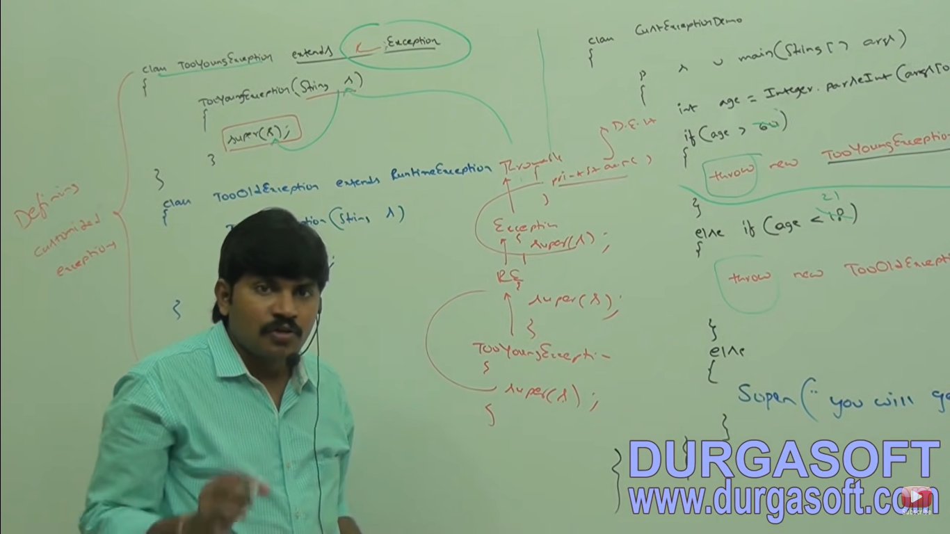

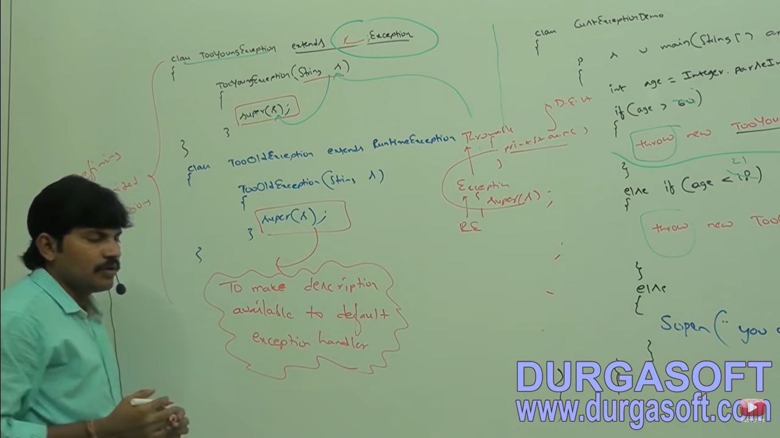

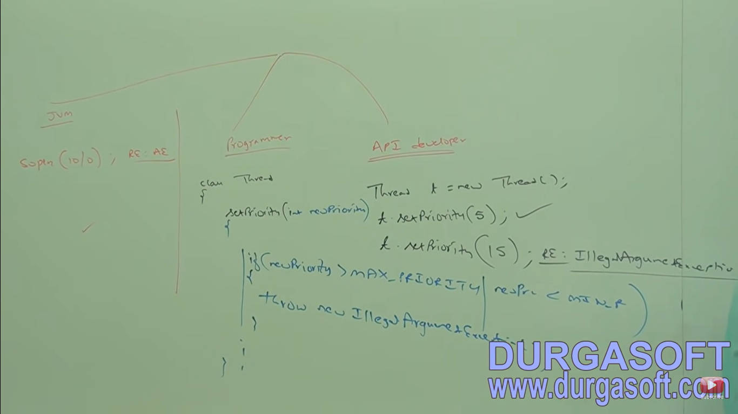

**Top 10 Exceptions**

Based on the person who is raising an exception all exceptions are divided into two categories:

1. JVM Exceptions
2. Programmatic Exceptions

**JVM Exceptions**

The exceptions which are raised automatically by JVM whenever a particular event occurs are called JVM Exception. Eg: Arithmetic Exception, Null Pointer Exception etc.

**Programmatic Exceptions**

The exceptions which are raised explicitly either by programmer or by API developer to indicate that something goes wrong are called Programmatic exceptions. Eg: TooOldException, IllegalArgumentException etc.

**ArrayIndexOutOfException**

ArrayIndexOutOfBoundException is the child class of IndexOutOFBoundException and in turn it is child of RuntimeException.

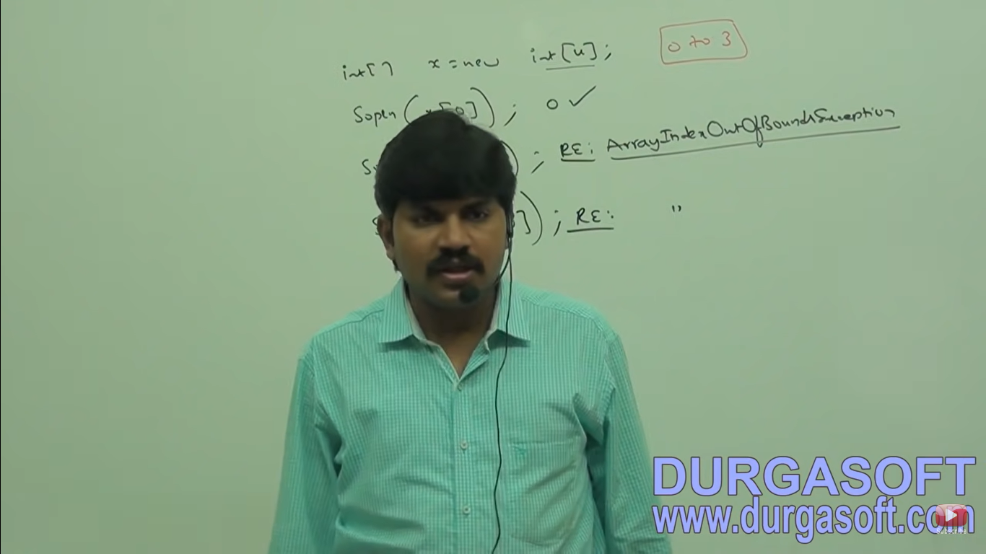

**NullPointerException**

It is the child class of Runtime Exception and hence it is unchecked raised automatically by JVM whenever we are trying to perform any operation on null.

String s = null;

Sopln(s.length()); //nullpointerException

**ClassCastException**

It is the child class of Runtime Exception and hence it is unchecked.

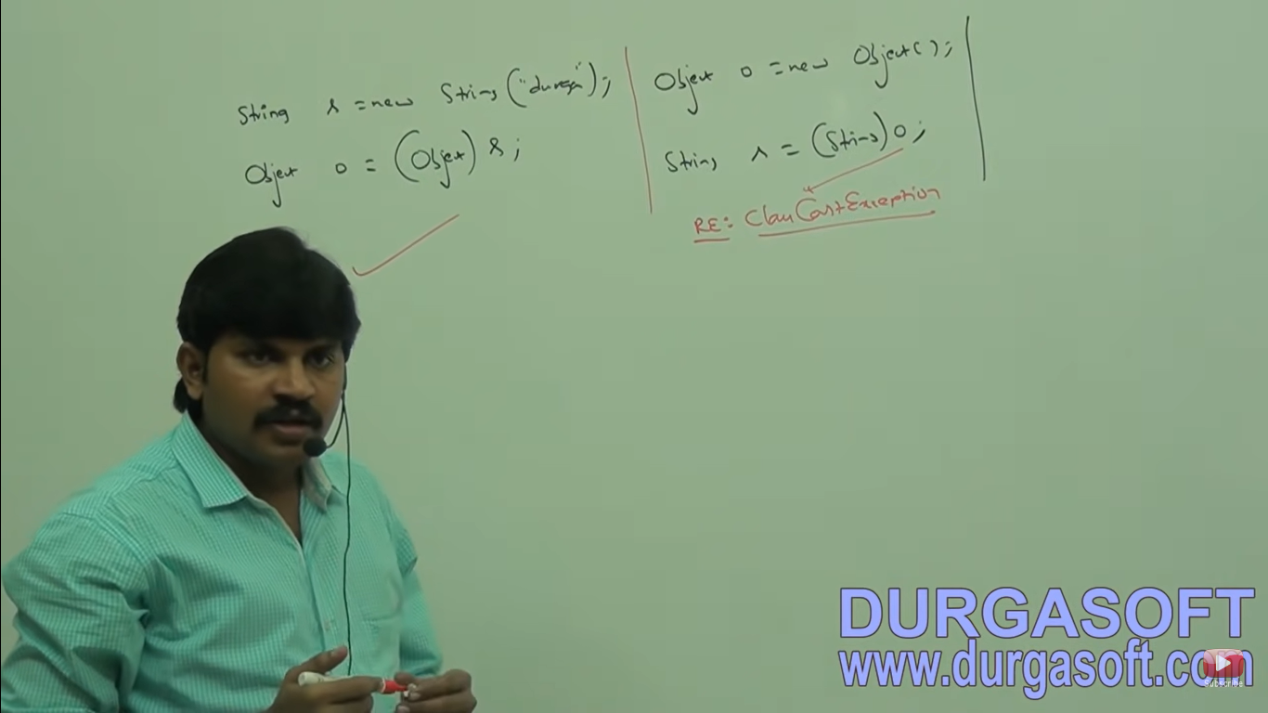

Raised automatically by JVM whenever we are trying to typecast parent object to child type.

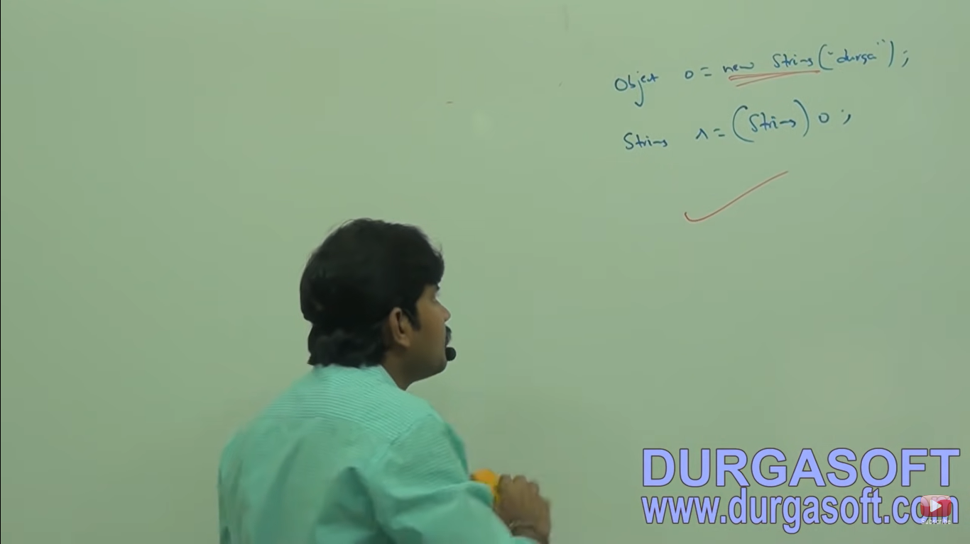

**StackOverflowError**

It is the child class of **error** and hence it is unchecked raised automatically by JVM. Whenever we are trying to perform recursive method call.

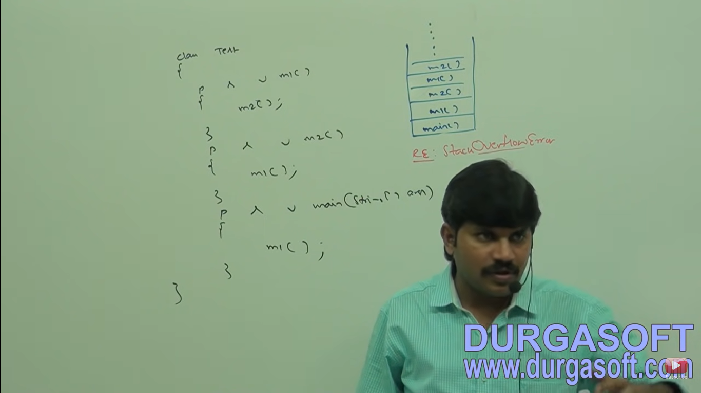

**NoClassDefFoundError**

It is the child class of error and hence it is unchecked.

Whenever JVM unable to find required .class file. Eg. Java Test

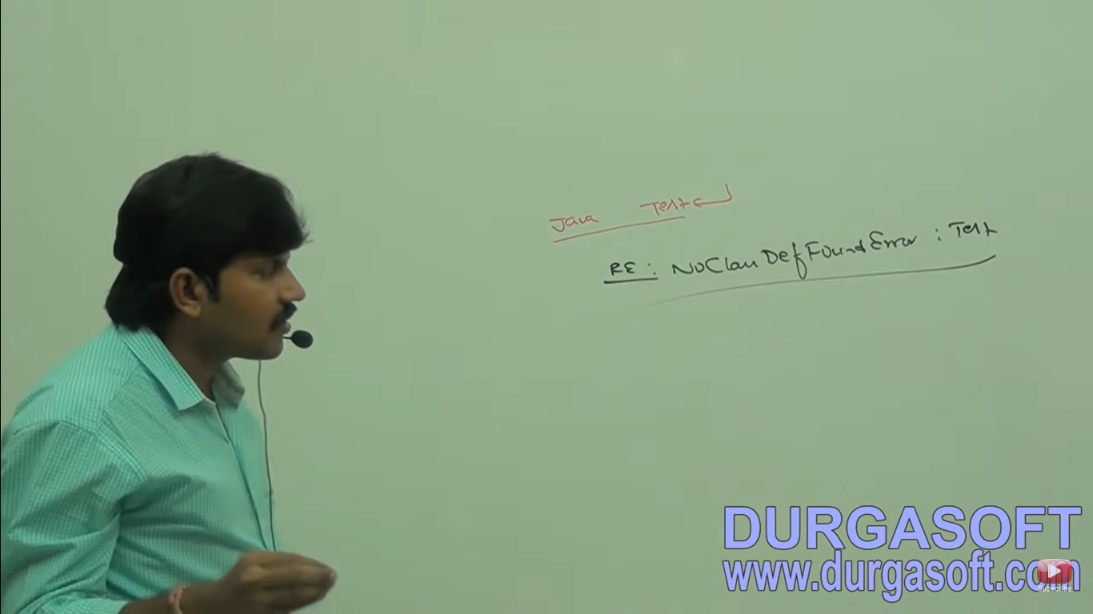

If test.class file is not available then we will get runtime exception saying NoClassDefFoundError: Test.

**ExceptionInInitializationError**

It is child class of error, hence it is unchecked.

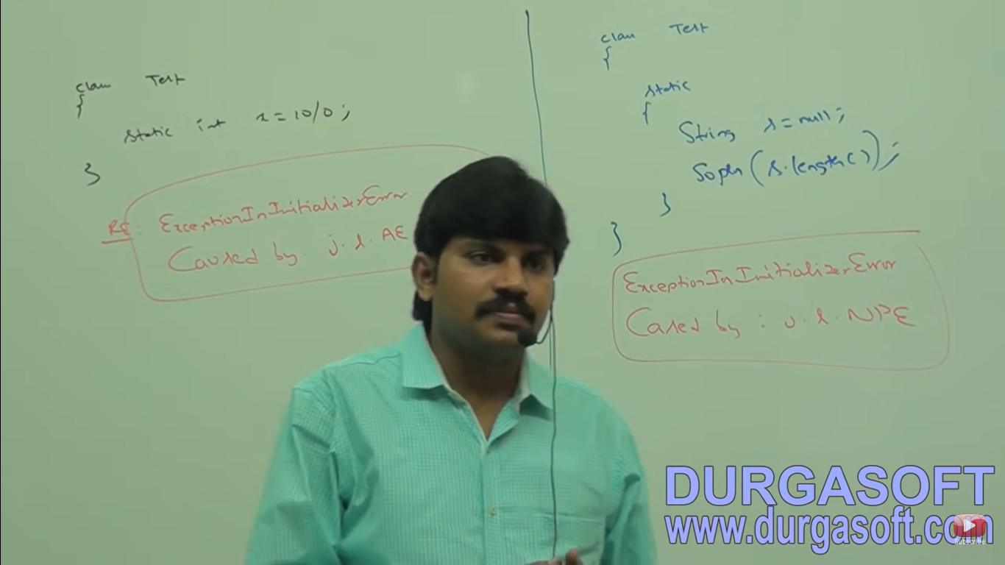

**IllegalArgumentException**

It is the child class of Runtime Exception and hence it is unchecked.

Raised explicitly either by programmer or by API developer to indicate that a method has been invoked with Illegal Argument.

Ex: The valid range of thread priorities is 1 to 10. If we are trying to set the priority with any other value then we will get RuntimeException saying IllegalArgumentException.

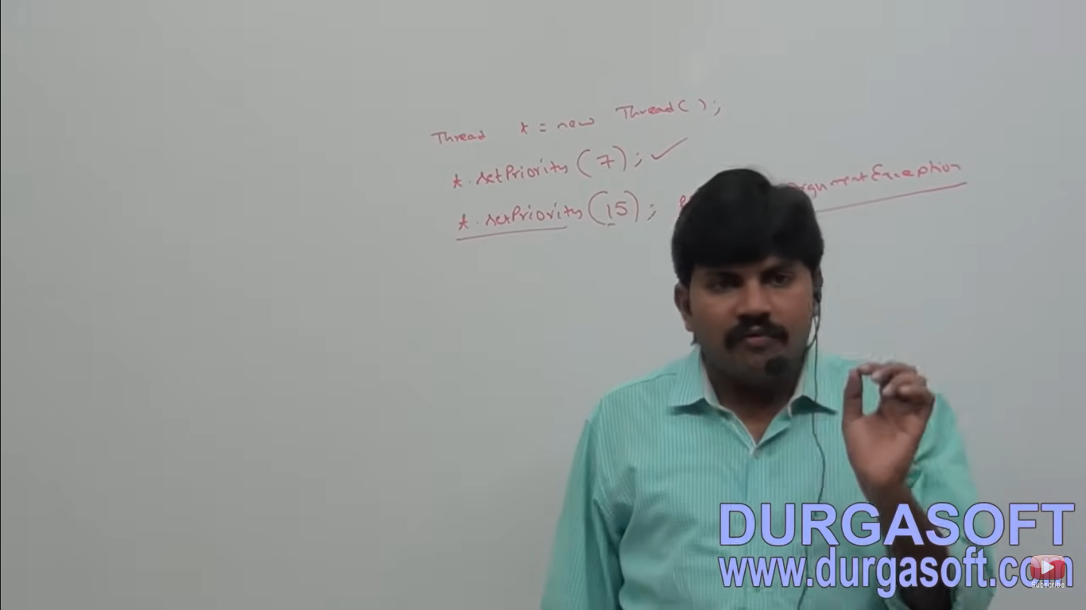

**NumberFormatException**

It is the direct child class of IllegalArgumentException which is the child class of RuntimeException and hence it is Unchecked exception.

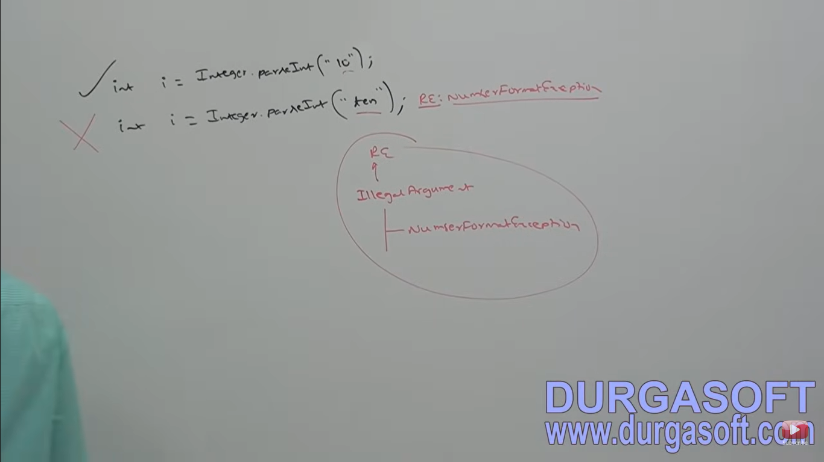

Raised explicitly either by programmer or by API developer to indicate that we are trying to convert String to number and the string is not properly formatted.

**IllegalStateException**

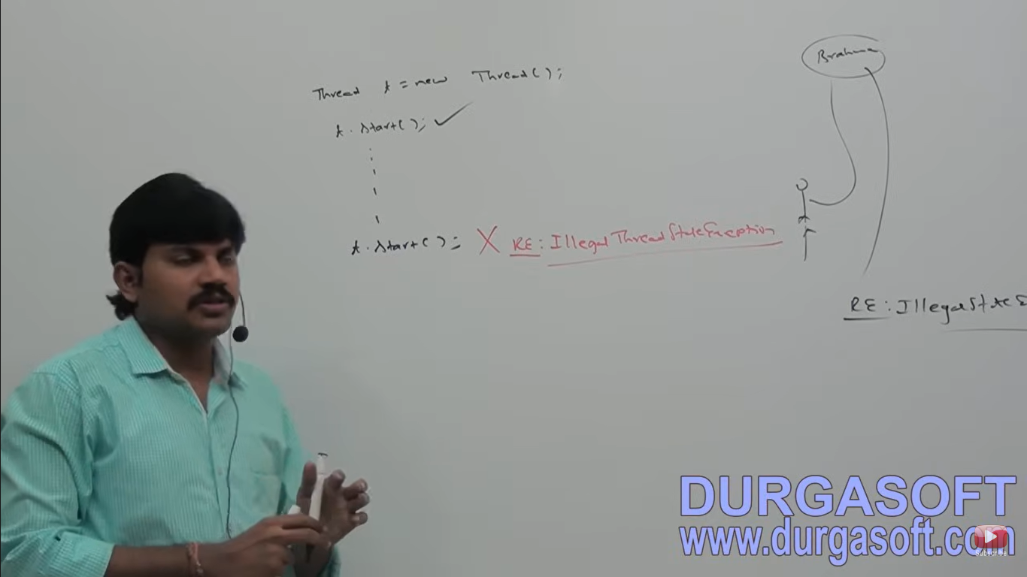

Raised explicitly by programmer or API developer to indicate that a method has been invoked at the wrong time.

Eg. After starting of a thread we are not allowed to restart the same thread once again otherwise we will get RuntimeException saying IllegalThreadStateException.

**AssertionError**

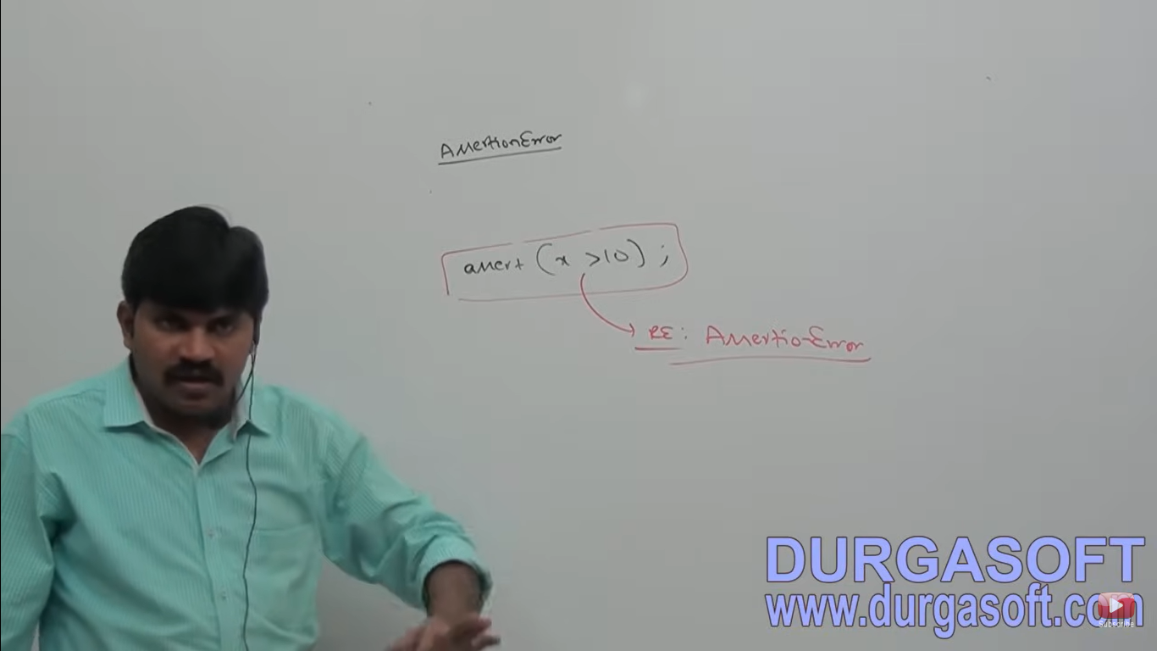

It is the child class of error and hence it is unchecked raised explicitly by the programmer or by PAI developer to indicate that assert statement fails.

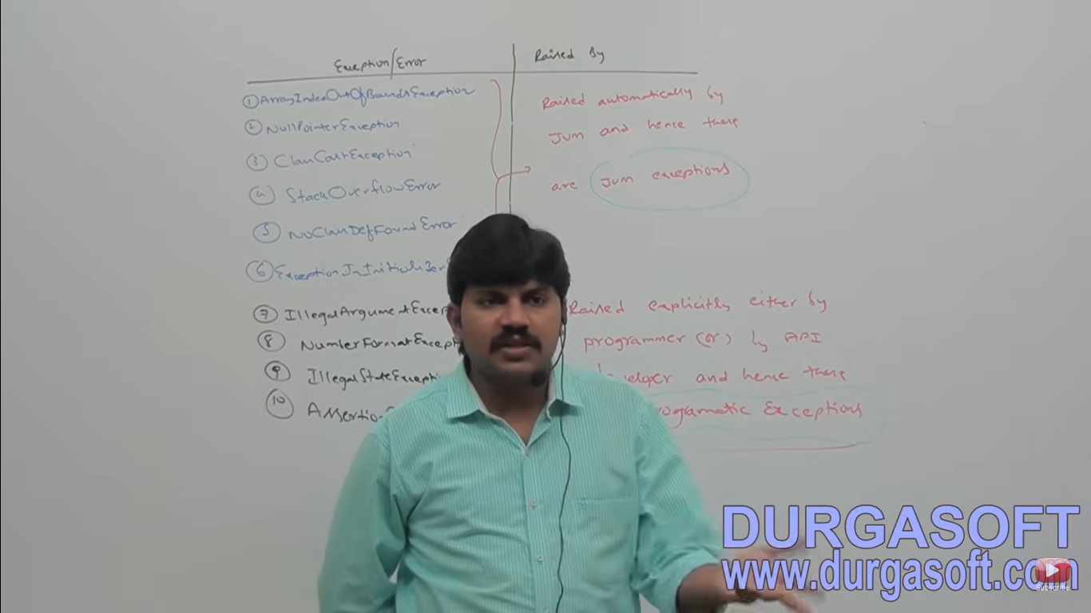

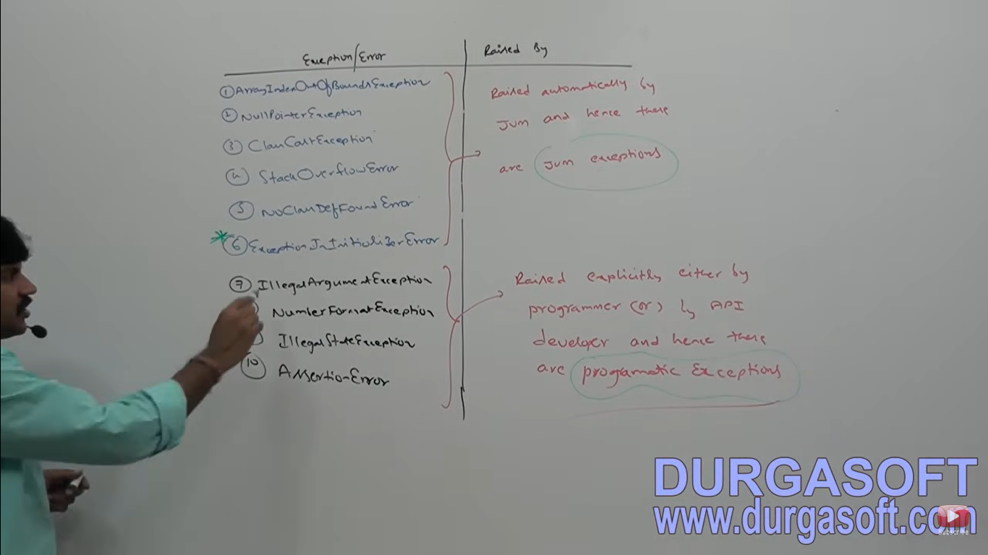

The following two concepts introduced in 1.7v:

1. Try with resources
2. Multiple catch blocks.

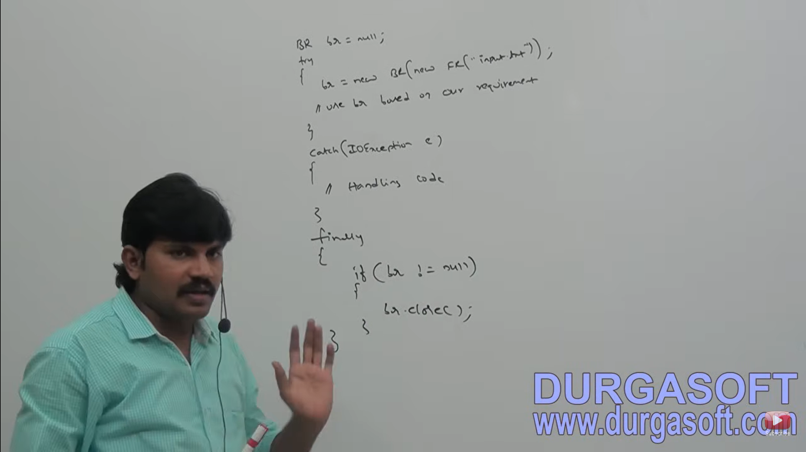

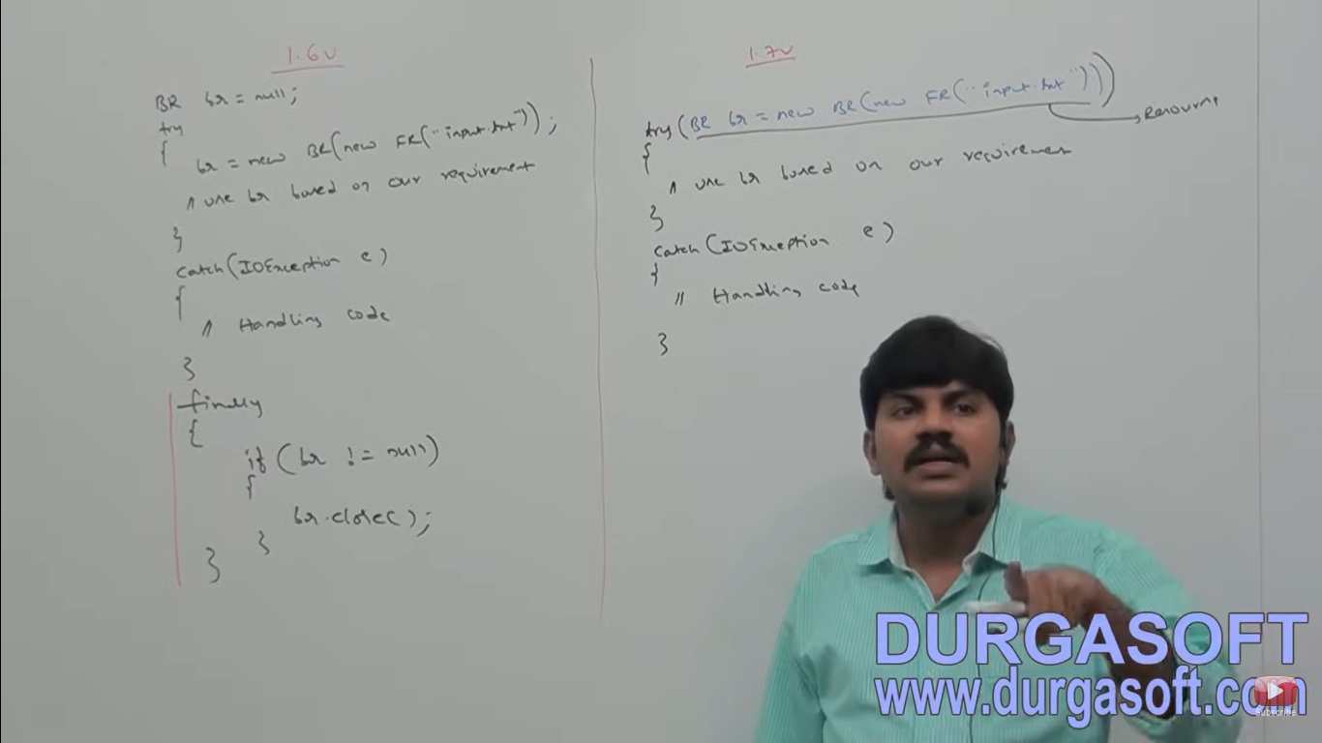

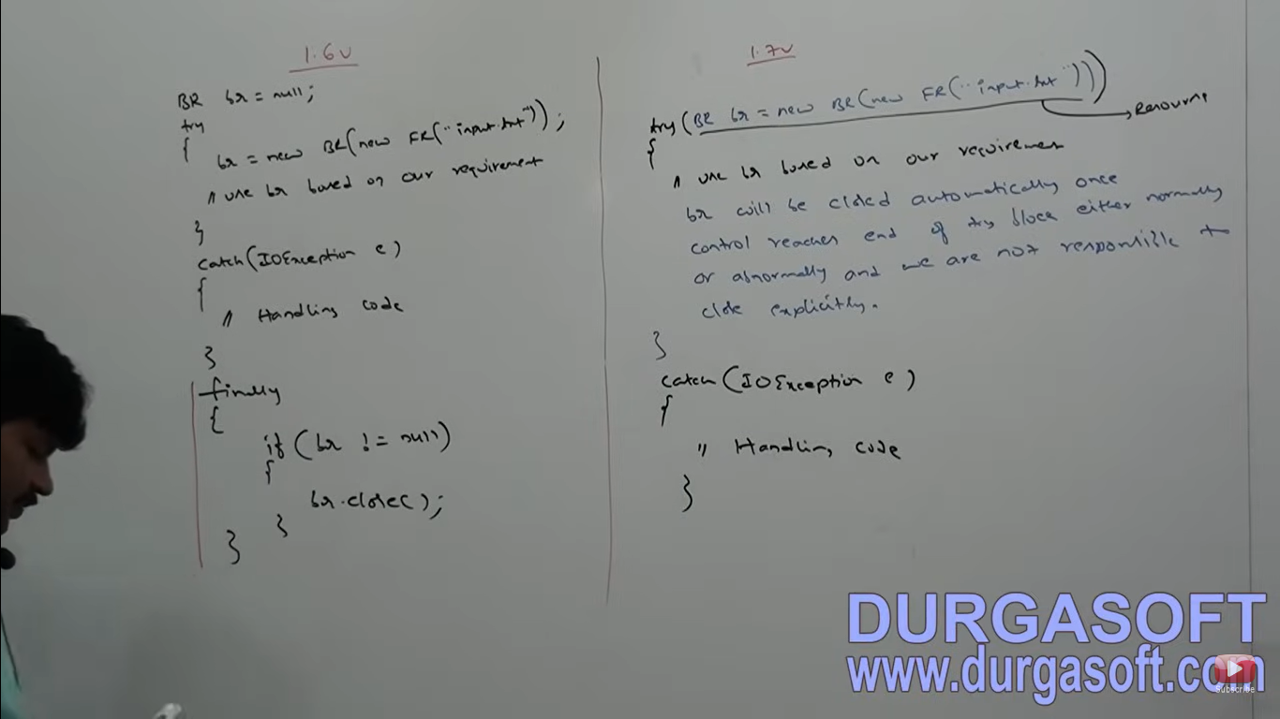

1 Approach – The problems in this approach are:

1. Compulsory programmer is required to close the resources inside finally block. It increases complexity of programming
2. We have to write finally block compulsory and hence it increases length of the code and reduces the readability.
3. To overcome above problems Sun people introduced try-with resources in 1.7v. The main advantage of try-with resources is whatever we resources we open as a part of try block will be closed automatically once control reaches end of try block either normally or abnormally and hence we are not required to close explicitly so that complexity of programming will be reduced. We are not required to write finally block so that length of the code will be reduced and readability will be improved.

Conclusions:

1. We can declare multiple resources but these resources should be separated with semicolon. 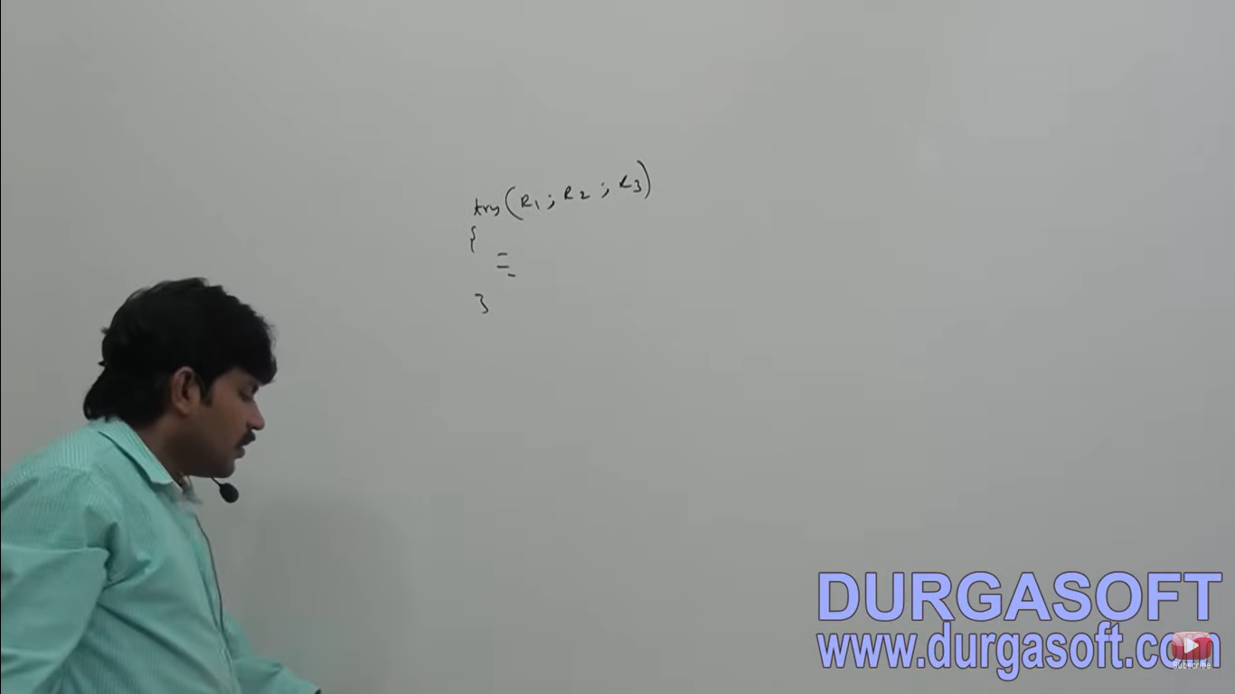
2. All resources should be auto closable resources. A reource is said to be autoclosable if and only if coreesponding class implements java.lang.autoclosable interface.

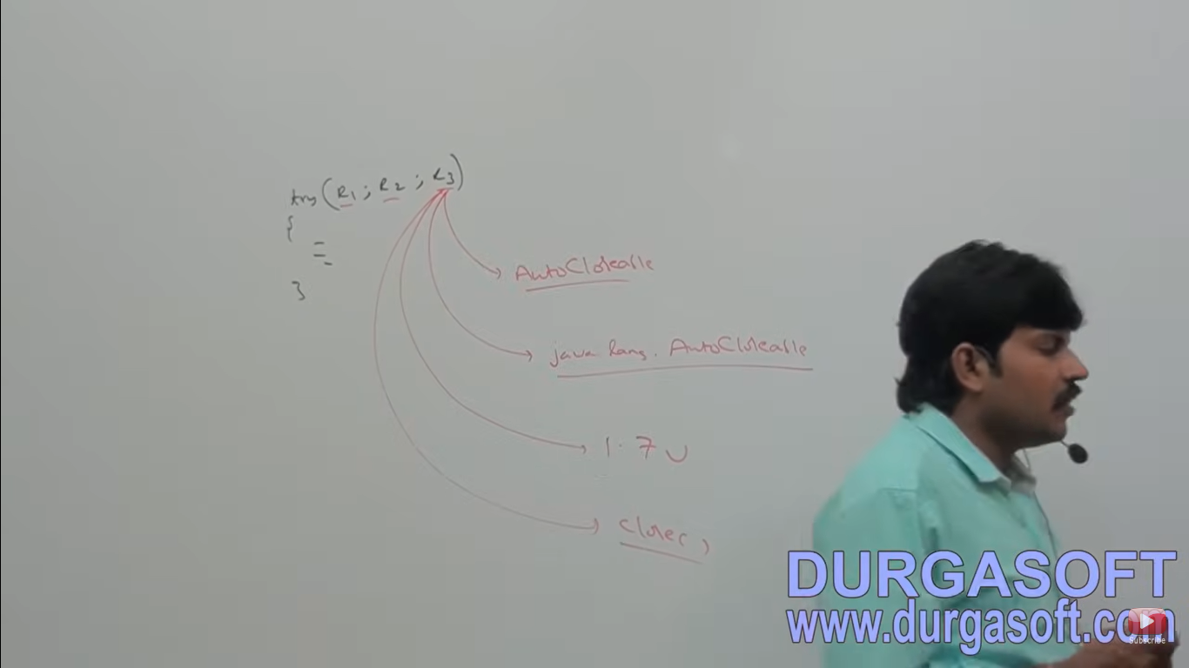

1. All resource reference variables are implicitly final and hence within the try block we can’t perform reassignment.

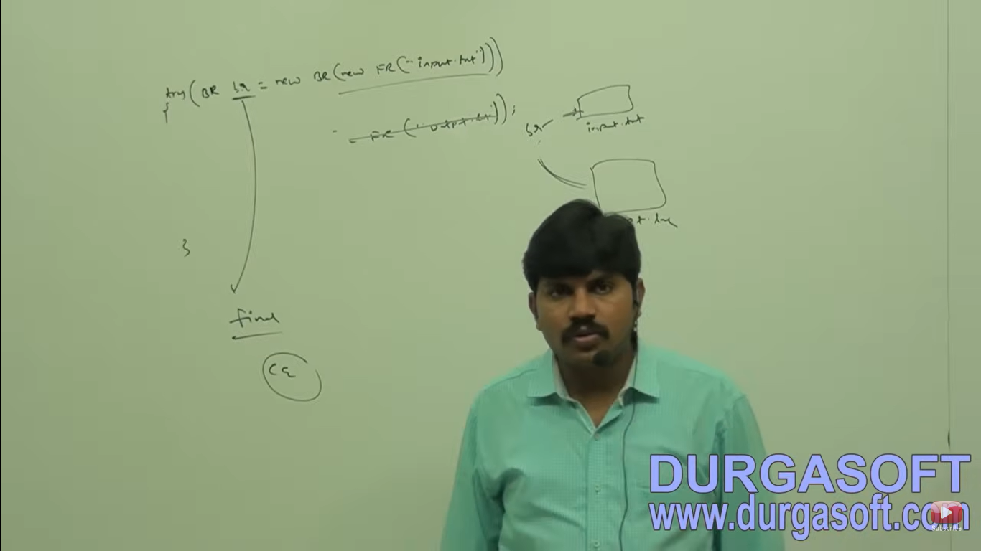

Case 4: Until 1.6v try should be associated with either catch or finally but from 1.7v onwards we can take only try with resources and without catch or finally block.

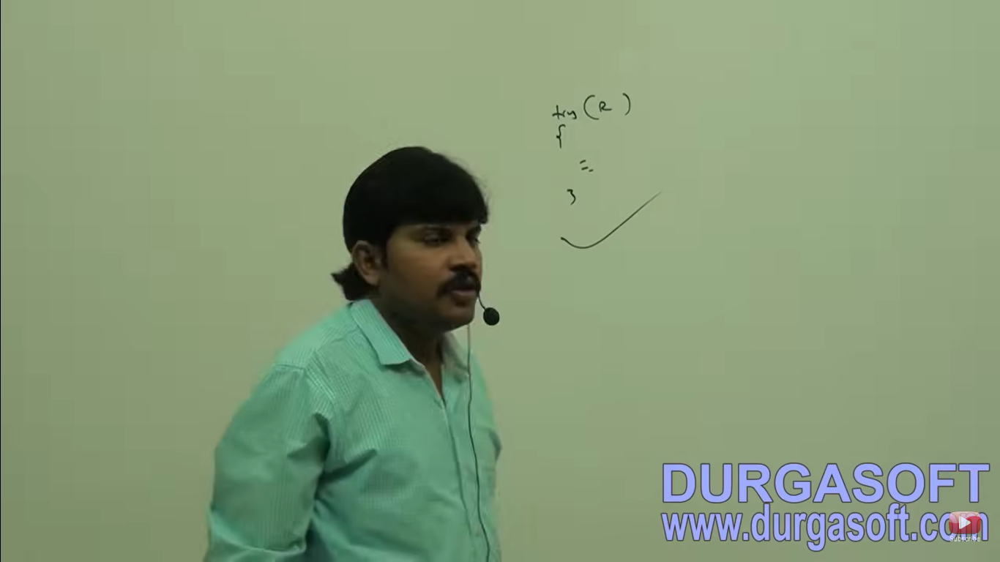

**Summary**

1. We are not required to close resource explicitly with try with resource hence until 1.6v finally block is just like hero but from 1.7v onwards it is dummy and becomes zero.

MultiCatch block

Until 1.6v even though multiple different exceptions having same handling code for every exception type we have to write a separate catch block. It increases length of the code and reduces readability.

Sun people Multi catch block in 1.7v according to this we can write a single catch block that can handle multiple different type of exceptions.

Whether the exception is Arithmetic Exception or Null pointer exception then the same catch block can listen.

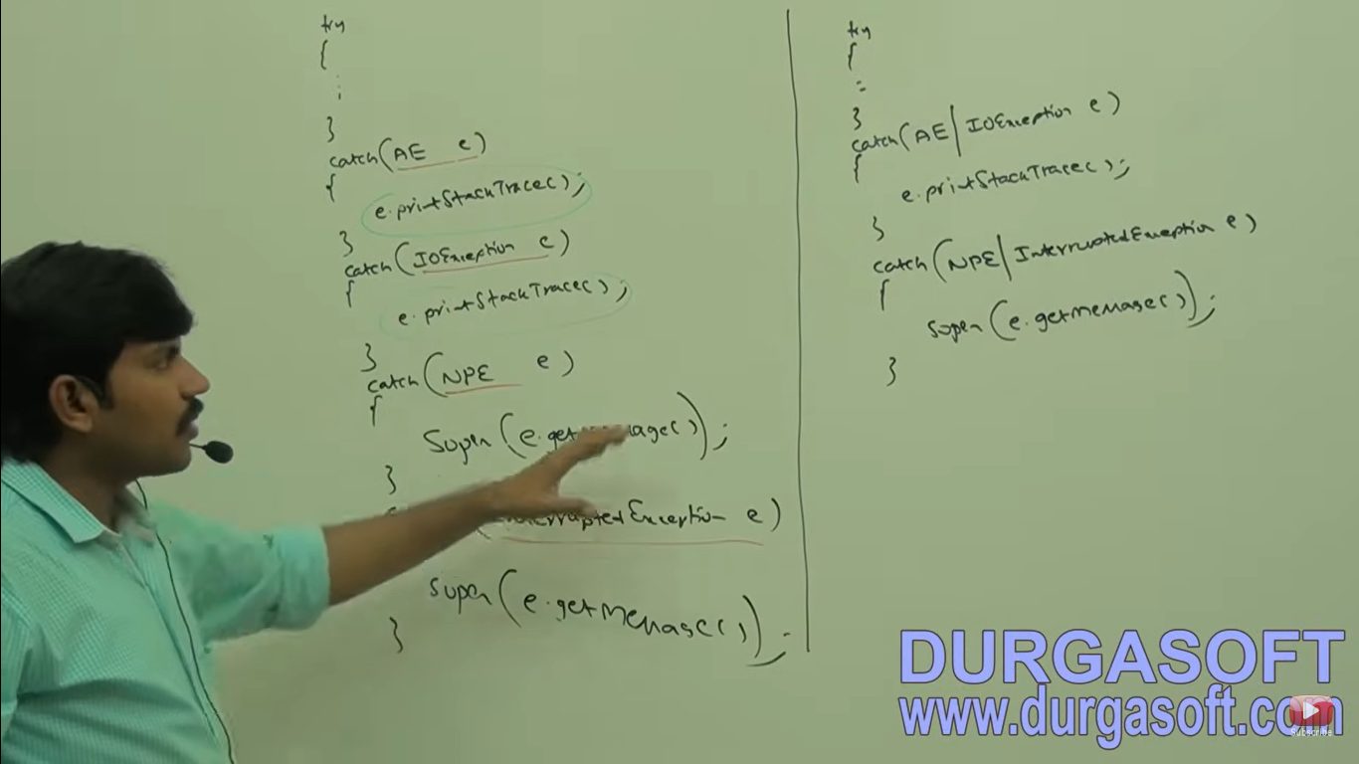

There should not be any relation between exception types (either child to parent) or (parent to child) or same type. Otherwise we will get compile time error.

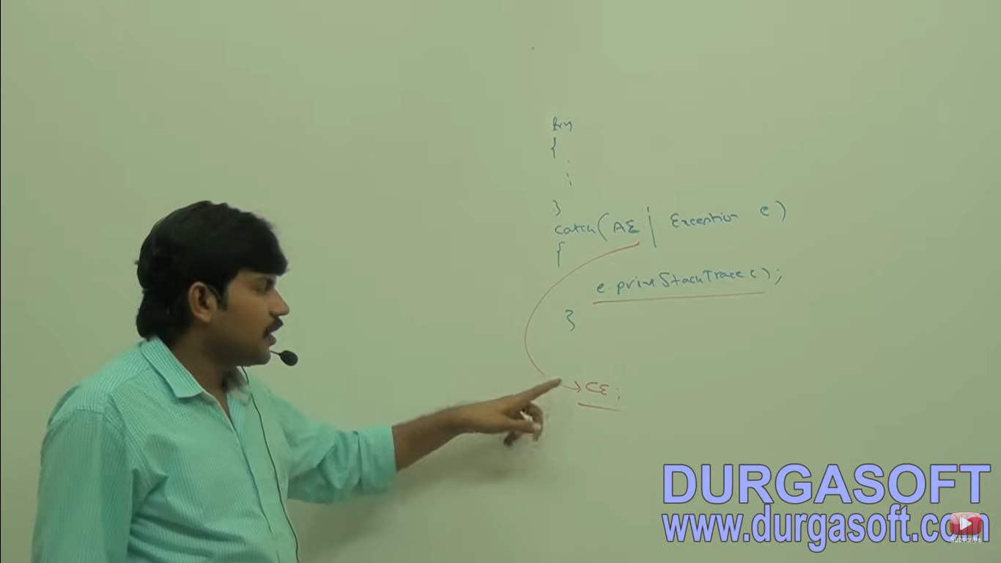

**Exception Propagation**

Inside a method if an exception raised and if we are not handling that exception then exception object will be propagated to caller then caller method is responsible to handle exception this process is called exception propagation.

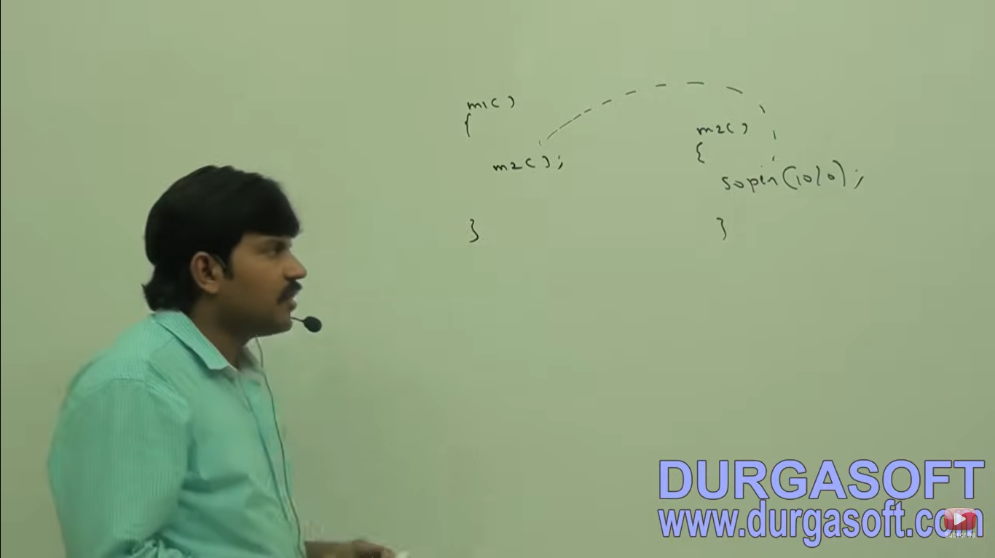

**Rethrowing Exception**

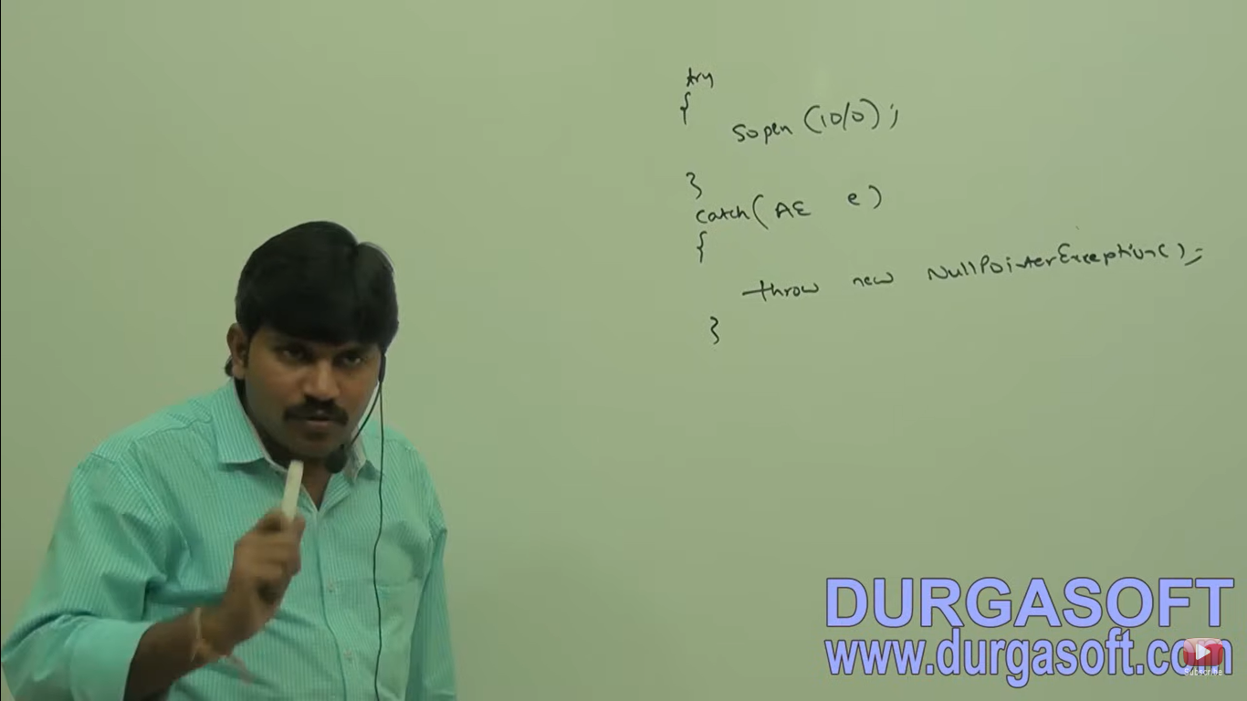

We can use this approach to convert one exception type to another exception type.